Legacy NC4 & Everbridge Feature Comparison

Legacy NC4 & Everbridge Feature Comparison

Legacy NC4 & Everbridge Feature Comparison

Legacy NC4 & Everbridge Feature Comparison
October 14, 2024

October 14, 2024
NC4 Migrations/Upgrades

NC4 Migrations/Upgrades

NC4 Migrations/Upgrades

NC4 Migrations/Upgrades
Legacy NC4 & Everbridge Feature Comparison 1
NC4 Intelligence 3
NC4 Analysis 7
NC4 Maps 9
NC4 Locations 11
NC4 Settings 15
NC4 Administration 29
NC4 Inbox 31
NC4 ActivTravel 33
NC4 Travelers 34

NC4 Intelligence
Real-time Incidents are the NIMC Advisories and NIMC Incidents layers in the Situation Map and Incident/Advisory Map. In Everbridge these sources are referred to as RIMC powered by NC4 and RIMC Advisories Risk Event sources/risk event feeds. NOTE: Incidents in NC4 is equal to Risk Events in VCC.

NIMC Incidents/RIMC Powered by NC4: Everbridge Risk Intelligence Monitor Center (RIMC) uses a team of analysts, leveraging many diverse information sources, to provide early warning of risk events at all levels, from neighborhood to international. The Risk Intelligence Monitoring Center combines thousands of trustworthy data sources with an experienced team of analysts to provide verified, real-time data about potentially threatening events around the world.

NIMC Advisories/RIMC Advisories: Advisories from the Risk Intelligence Monitoring Center are derived from thousands of trustworthy data sources and curated by an experienced team of analysts. They provide global intelligence about ongoing and future safety, security, and health risks.

Real-Time Incidents:
- Incident/Advisory Map is all current open Incidents visualized on a map. In VCC Operator Console you can filter you map to view Risk Events by source and/or category and by time through the timeline panel.
- Incident Explorer is all current open Incidents in a list format. In VCC Operator Console, you can enable Risk Events as mentioned above, and then you can view more information in list or grid view in the items panel. You can also export risk events in a csv file.

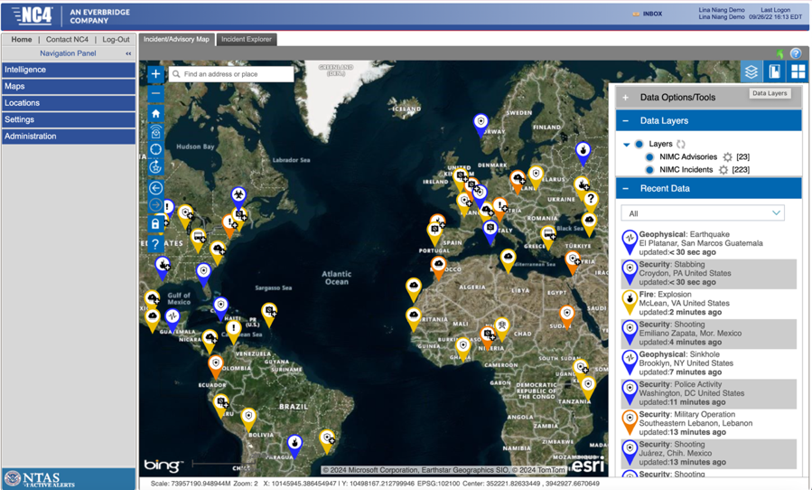

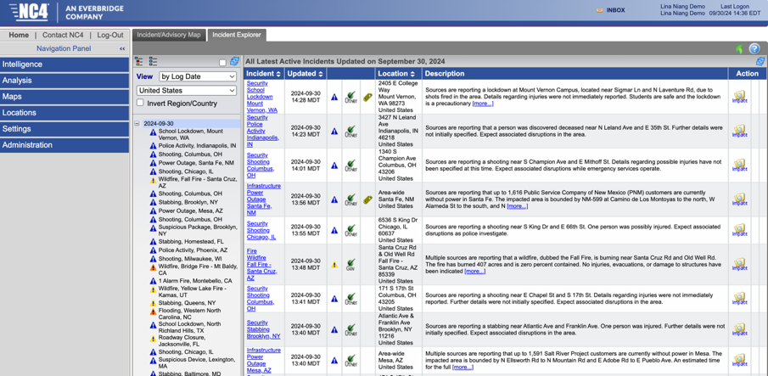

The Everbridge Visual Command Center (VCC) Operator Console is like the NC4 Situation Map. The Items Panel will display the content visualized on the map in a list or grid view format. The information can also be downloaded to excel.

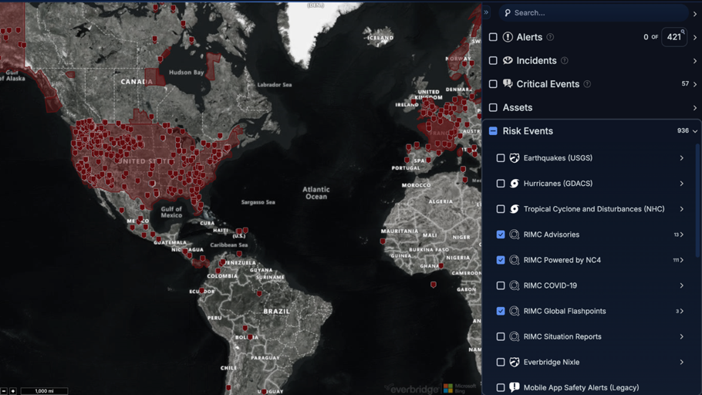

Global Flashpoints = RIMC Global Flashpoints source/risk event feed in Everbridge.
Global Flashpoints from the Risk Intelligence Monitoring Center provide summaries and analyses of events or conditions in a country. Each Flashpoint includes the assessment of RIMC’s professional analysts about the potential impact on travel and security.

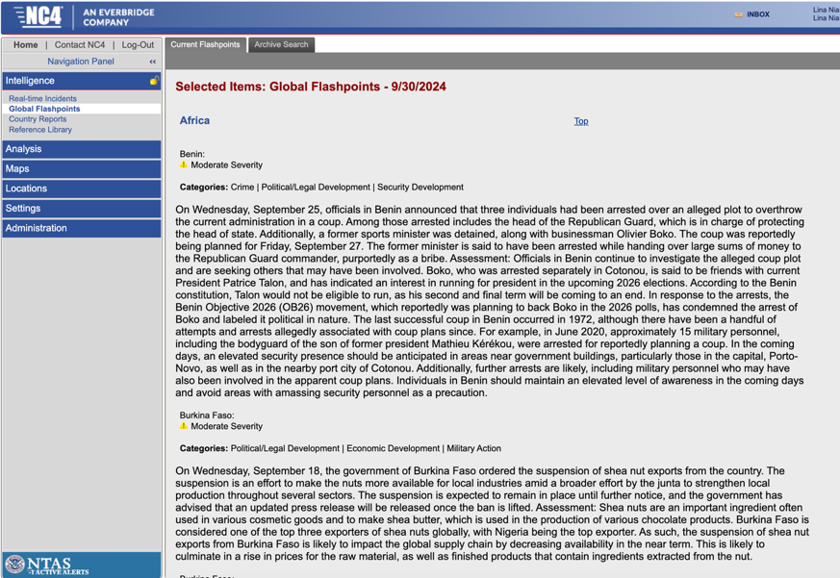
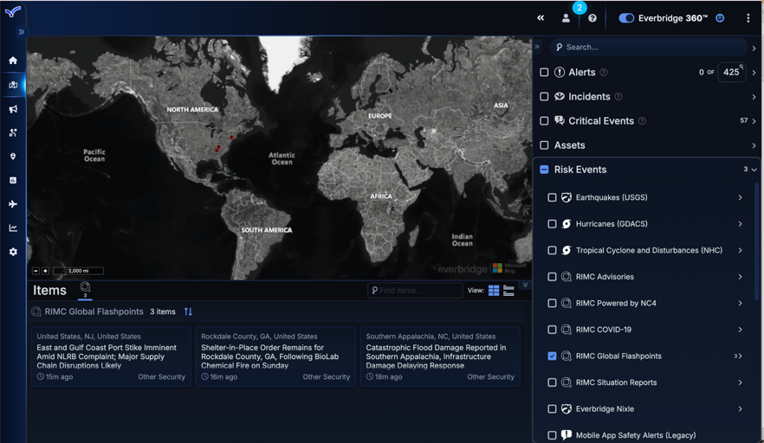

Country Reports = In the Context feed in VCC Operator Console, there is a RIMC Country Ratings contextual layer. When enabled, you can view a link to the Pre-trip Country Reports (Travel Risk Intel) in the Items Panel.

Country Reports in NC4

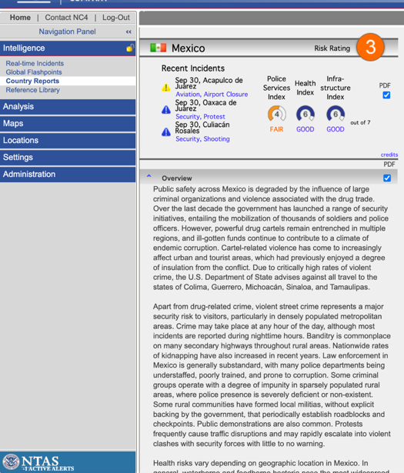

Country Ratings and Travel Risk Intelligence/Country Reports in VCC

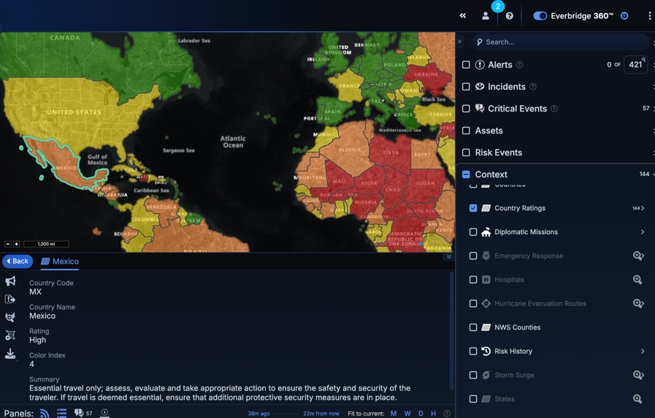
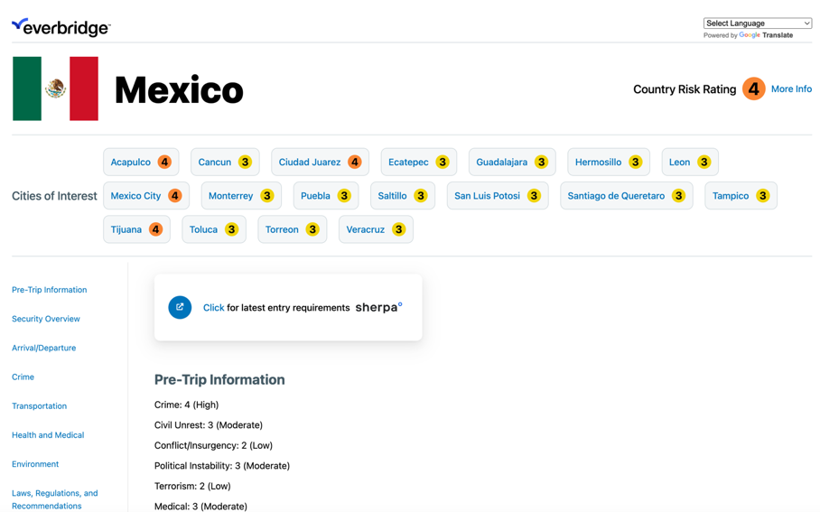

NC4 Analysis
Global Intelligence Relays are not available in VCC Operator Console. The comparable option is to download an export of your Active and Acknowledged Alerts in a csv/list format. This would download all Alerts based on map view or timeline panel, you cannot configure list by workflow (alert profile) that triggered the alert, and a PDF summary view is not available.

Situation Reports is equivalent to the RIMC Situation Report source/risk event feed in VCC Operator Console. The URL under the More Information section of the Situation Report in the Items Panel provides a downloadable PDF of the report.

Situation Reports from the Risk Intelligence Monitoring Center (RIMC) provide timely, in-depth, contextual information about events that may impact organizational strategic planning, assets, supply chain resiliency, and traveler and corporate security. These long-form reports include the latest developments of tactical and strategic importance on complex events worldwide. Situation Reports may also cover complex, long-term developments around the globe such as terrorism, drug wars, piracy, and civil unrest. Also covered are significant outbreaks of infectious diseases, particularly virulent and widespread seasonal illnesses and health related developments.

NC4 Situation Reports

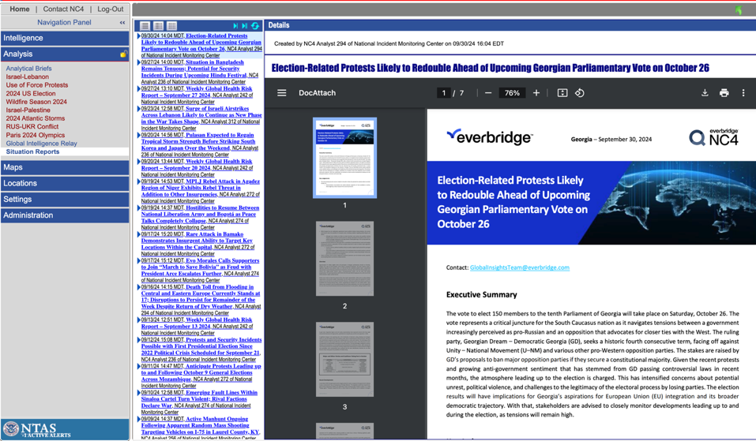

RIMC Situation Reports in VCC

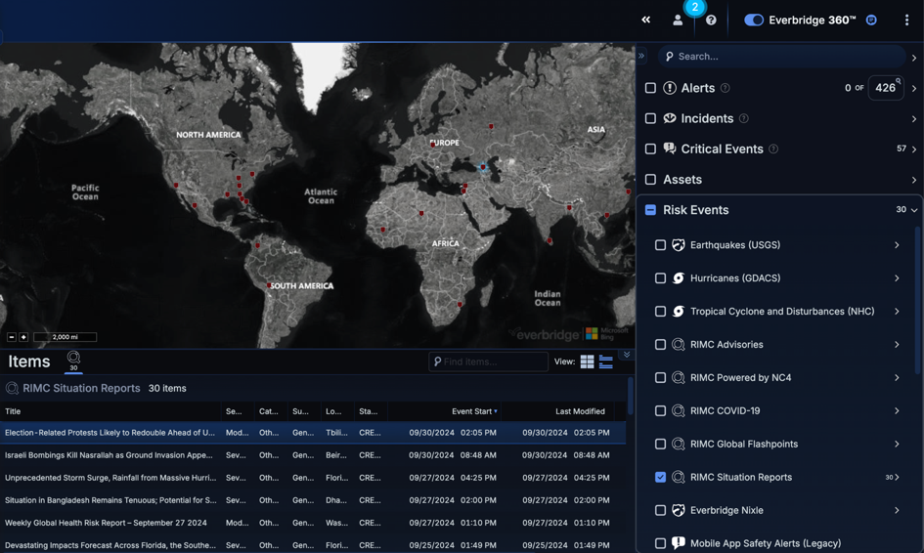
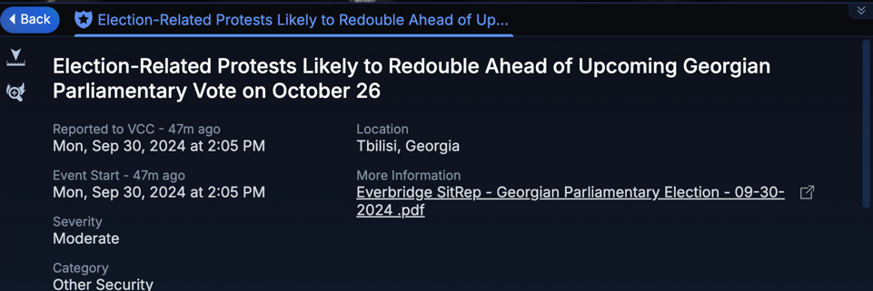

NC4 Maps
Situation Map (R10) is equal to the VCC Operator Console Map. What you see on the VCC map is based on the feeds selected and the timeline panel filter. You can enable the Alerts feed to view Alerts (proximity warnings) triggered based on your CEM Orchestration Workflows (equivalent to NC4 Alert profiles). Assets are equivalent to Locations in NC4. Risk Events are equivalent to Incidents in NC4.

NC4 Data Layers vs VCC Operator Console Feeds:
- Locations = Assets or Buildings under Assets (this can also include Contacts)
- NIMC Advisories = RIMC Advisories under Risk Events
- NIMC Incidents = RIMC Powered by NC4 under Risk Events
- GFP = RIMC Global Flashpoints under Risk Events
- US Zip Codes = Zip Codes under Context
- ActivWeather = Weather Events (US) under Risk Events
- Fire = Wildfires (NIFC) under Risk Events

Situation Map in NC4
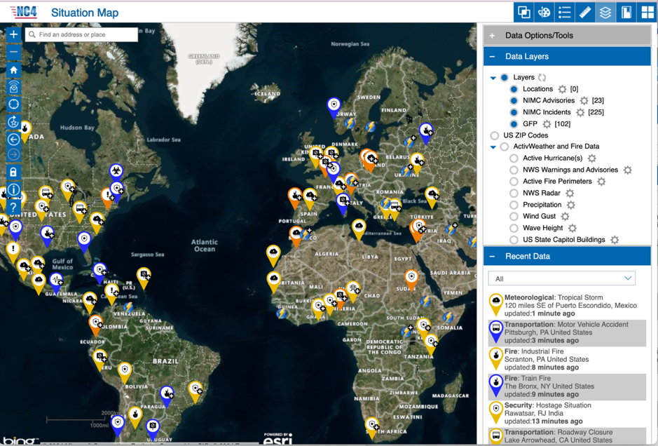

VCC Operator Console
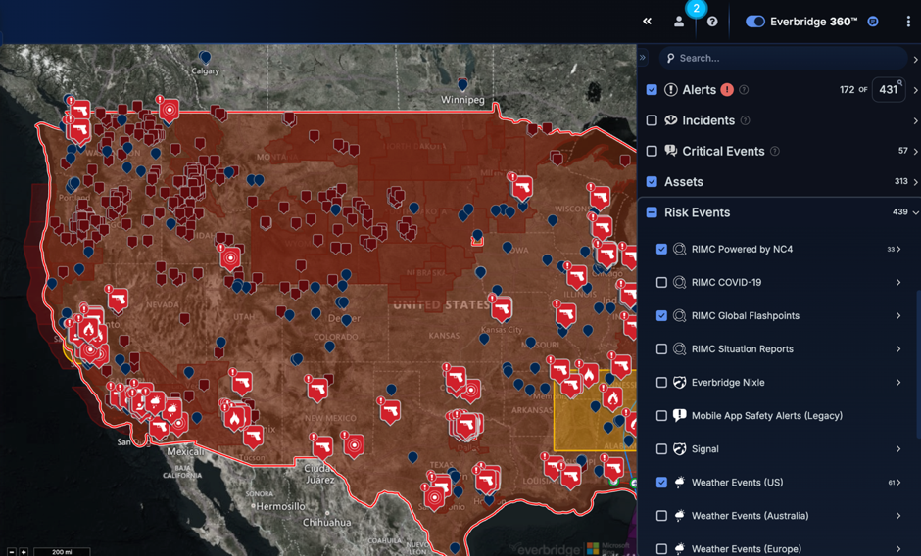

The items panel in VCC Operator Console will allow you to view more details on information on the map in either grid or list view.

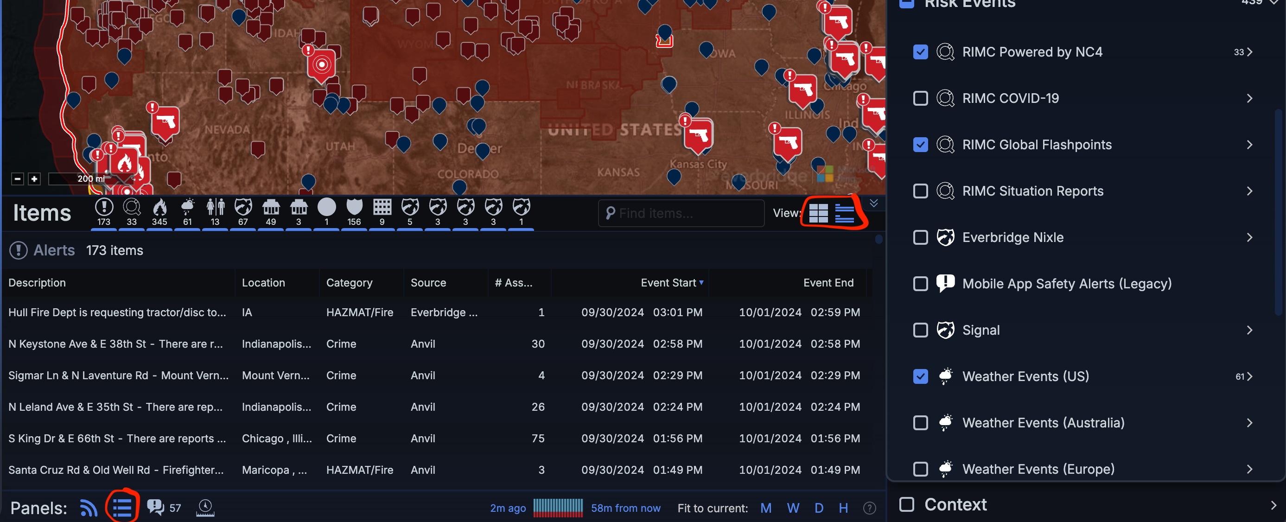

NC4 Locations
Location Reports and Tools
Location Reports – pre-canned reports to view location data. In VCC Operator Console, you can visualize and export Assets on the map. You can enable the Asset feed, but also adjust map to only show you Assets in a certain location on the map. You can add filters to your Asset Types to be able to filter asset data down further on the map. The filters are based on data attributes available in your Asset profiles and completely customizable. You can export assets by right clicking the asset type and selecting download, or going to the three dot icon in the top right hand corner and select excel report.

Exporting Location Reports in NC4
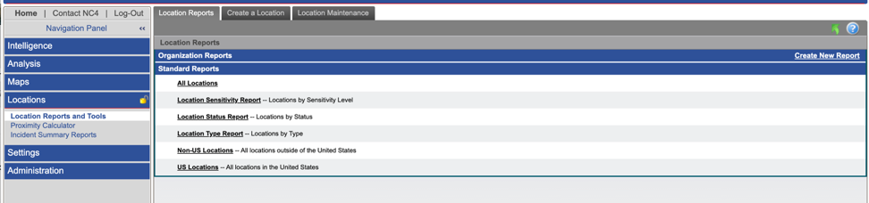

Exporting Asset Reports from VCC
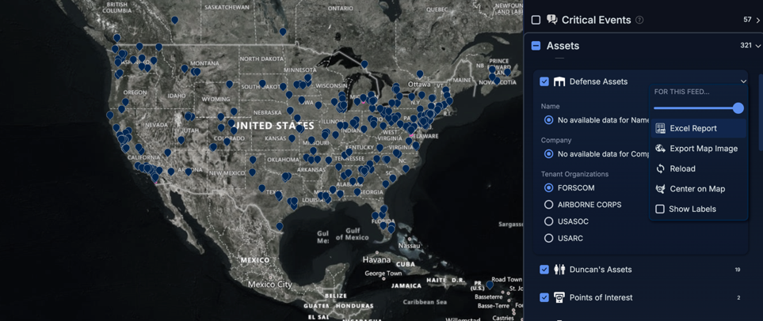

Create a Location – manually create location. In Everbridge Suite Manager Portal under Contacts/Assets > Assets > Add Asset. Reference the Asset Management User Guide in the Everbridge Support Center for more information on managing Assets.

Creating a Location in NC4
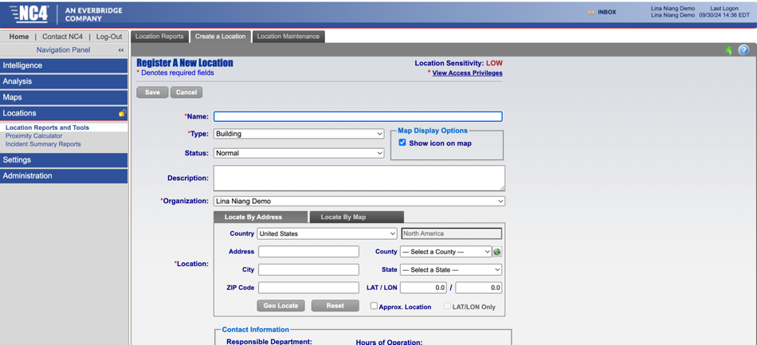

Creating an Asset in Everbridge
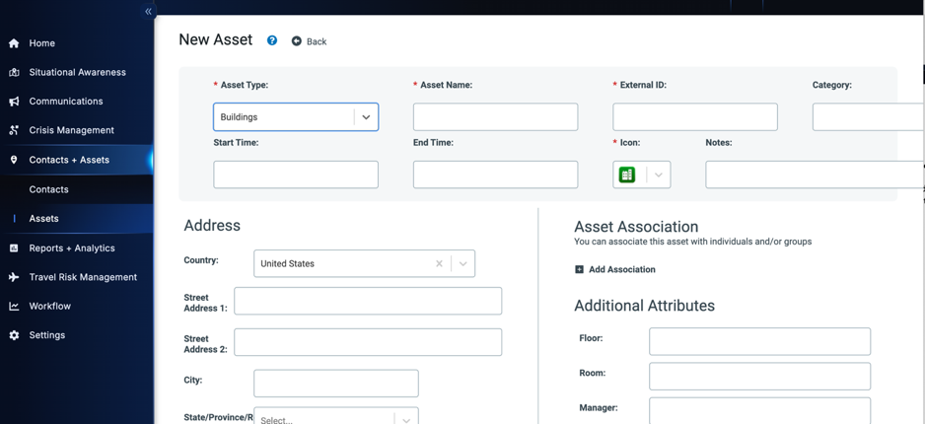

Location Maintenance – export or import locations. In Everbridge Suite Manager Portal under Contacts/Assets > Assets > Asset List > Download to export a list of Assets, and Contacts/Assets > Assets > Upload Assets to manually import Assets. You can also automatically manage Assets via SFTP or API.

Importing or Exporting Locations in NC4
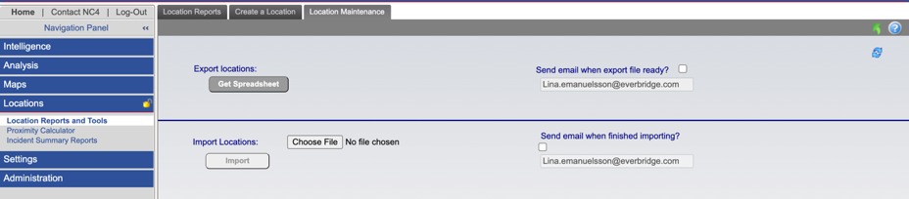

Importing or Exporting Locations in Everbridge
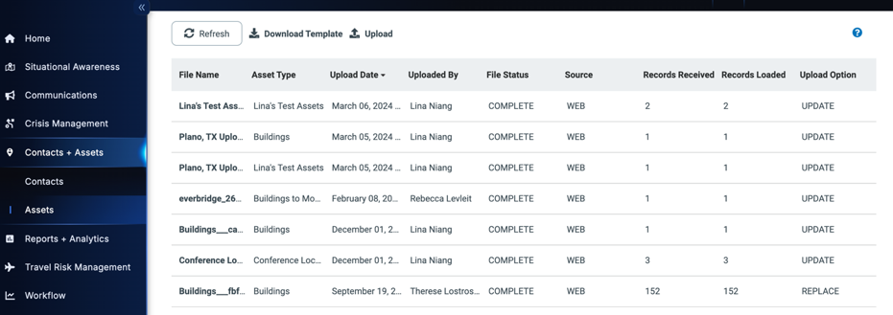

Proximity Calculator in NC4 shows a list view of risk events within a certain proximity of locations. In Everbridge, the Resilience Insights Risk Event Location Analysis Dashboard is the closest equivalent.

Proximity Calculator in NC4
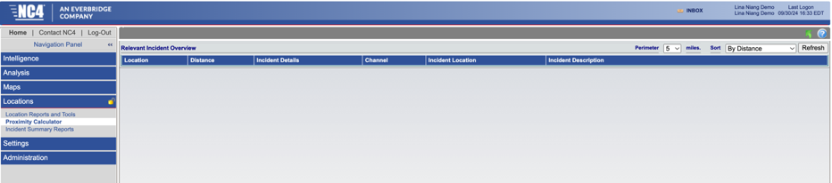

Risk Event Location Analysis Dashboard in Everbridge (Resilience Insights Add-On)
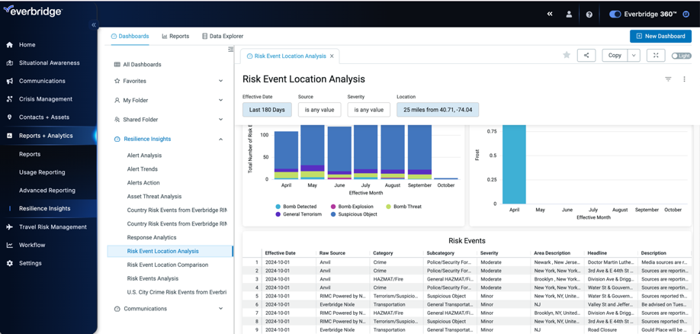

Incident Summary Reports in NC4 allow Users to subscribe to periodic reports which will be automatically sent to them via email. These reports are equivalent to Resilience Insights Dashboards. The Weekly Intelligence Brief Spotlight URL is also available to you.
- Location Summary = Risk event Location Analysis (all risk events) or Alert Analysis filtered by location (only alerts) Dashboards under Resilience Insights
- Incident Proximity Summary = Asset Threat Analysis Dashboard under Resilience Insights
- Brief Overview = Alert Analysis Dashboard or Risk Event Analysis Dashboard under Resilience Insights
- Detailed Incident Report = Alerts tabular view widget of the Alerts Analysis dashboard or the Risk Events tabular view widget of the Risk Event Analysis Dashboard

Incident Summary Reports in NC4
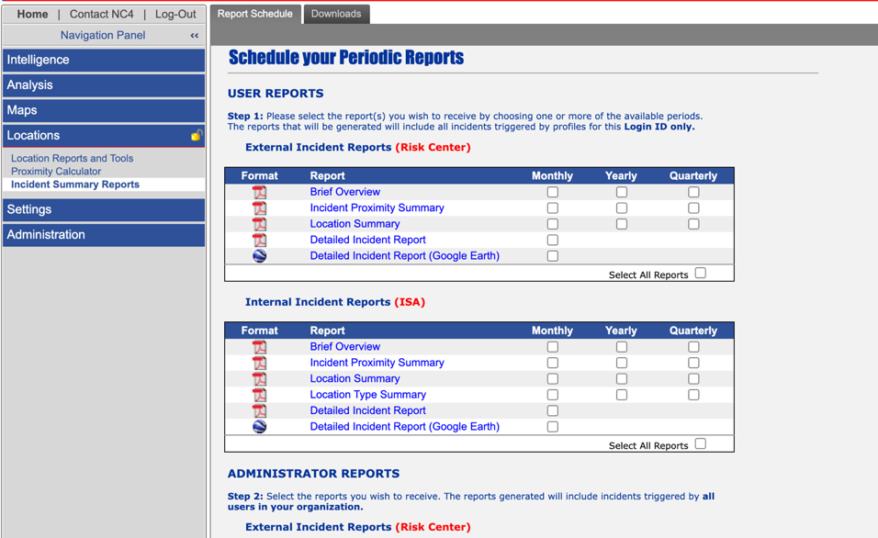

Resilience Insights Dashboards and Reports in Everbridge
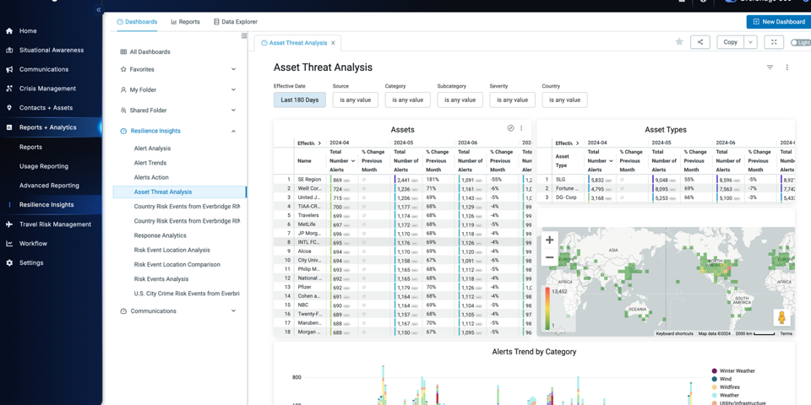

NC4 Settings
Alert Profiles is equivalent to CEM Orchestration Workflows in Everbridge Suite Manager Portal. In NC4, there are three basic profile types for which you can create specific Alert Profiles
- Real-time Intel = RIMC powered by NC4 and RIMC Advisory sources in Everbridge CEM Orchestration workflows
- Other Intel = RIMC Global Flashpoints and RIMC Situation Reports sources in Everbridge CEM Orchestration workflows
- ActivWeather = Weather Events (US) source in Everbridge CEM Orchestration workflows

Alert Profiles in NC4
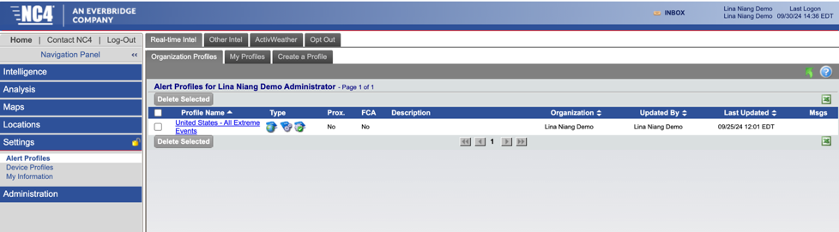

CEM Orchestration Workflows in Everbridge
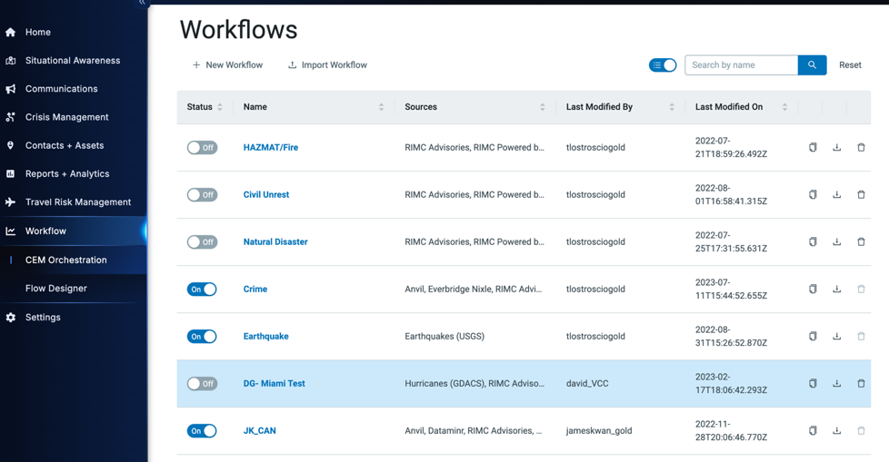

Real-Time Intel Profiles: NC4 analysts specify the incident category, sub-type and severity level of real-time incidents and advisories, geo-locating the incident to a specific latitude and longitude. Using this criteria – category, type, severity and location – you can create a Real-time Intel Alert Profile so that you only receive alerts pertaining to incidents that could impact your organization and/or fall under your scope of responsibility.

This is equivalent to creating CEM Orchestration workflows in Everbridge with the RIMC powered by NC4 and RIMC Advisories sources.

Real-Time Intel Profiles - Overall Settings in NC4
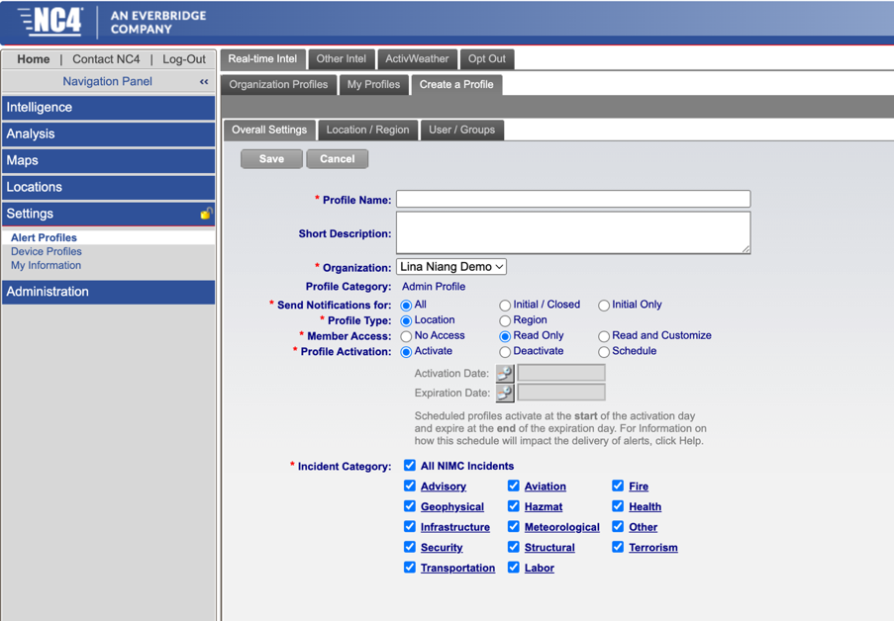

CEM Orchestration Workflow Anatomy in Everbridge
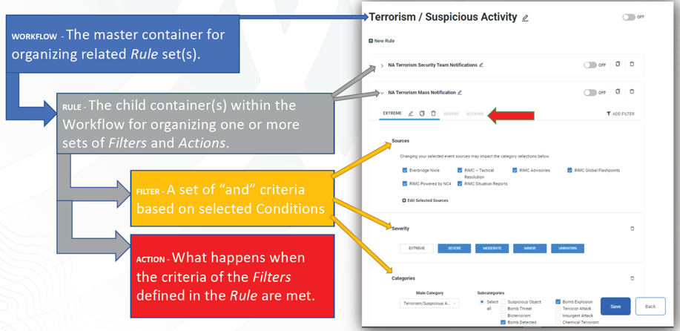

NC4 Alert Profile Name = CEM Orchestration Workflow Name, Ruleset Name and Filter Name. There are more layers in workflows when creating your Alert thresholds.

NC4 Alert Profile Sent Notifications for = CEM Orchestration ‘Action’ section of the Workflow ruleset and ‘When to Notify’ (image below)

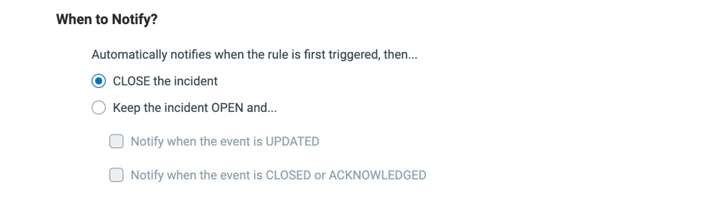

NC4 Alert Profile Activation = ON/OFF Status on CEM Orchestration Workflow, and Ruleset level.
NOTE: the ability to schedule a profile is not available with Workflows, but you can add a start time and end time on an Asset profile which determines when the Asset is alertable.

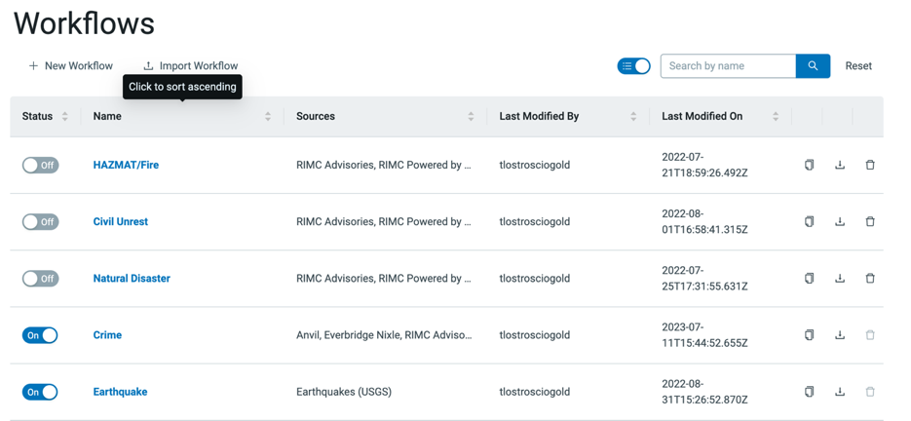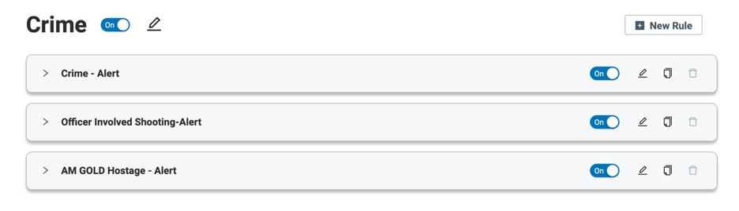

Adding a Start/End Time to an Asset Profile in Everbridge
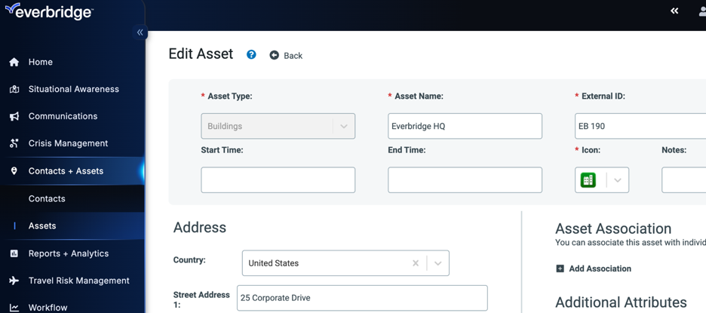

Profile Type in Everbridge ties back to Asset profiles in Asset Management and Contacts and Assets condition in the workflow ruleset filters.
- Region Based profile in NC4 is equivalent to creating a polygon shaped/geometry boundary Asset in Everbridge. Regions are not pre-defined in Everbridge, you must create the region assets/asset types.
- Location Based profiles trigger Proximity Warnings which are equivalent to Alerts in VCC (red icons in the VCC Operator Console map). You can upload Locations as Assets in Everbridge, and you can leverage Asset Types or Asset Tags for map visualization and alerting use case needs.
  - Facility Contact Alerting in NC4 is equivalent to Asset Association in Everbridge – You can create association labels, define the Contacts or Groups for the association label for each Asset and then automatically send an Incident Notification to the Contacts associated with the Asset that is impacted by an Alert.

Contacts and Assets condition in a CEM Orchestration Workflow ruleset filter
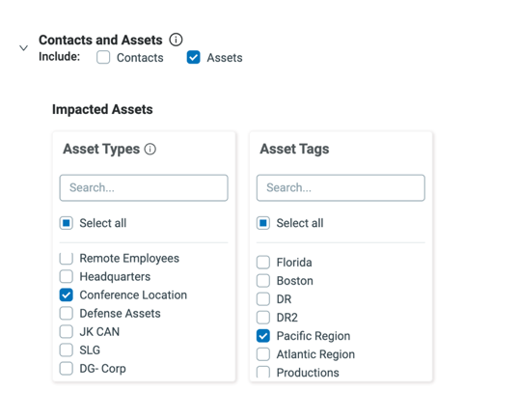

Facility Contact Alerting in CEM Orchestration Workflow Action
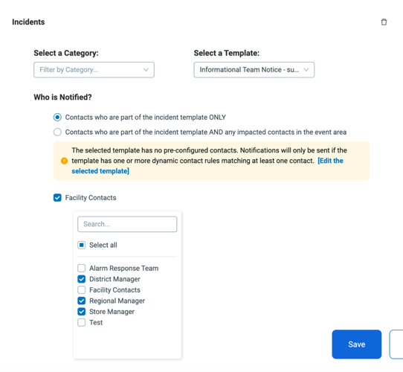

Real-Time Intel Profile - Location/Region
Depending on your profile type selection, you will either select the region(s) or select from your registered locations in the Location/Region section of the profile. You then defined the radius threshold by severity.

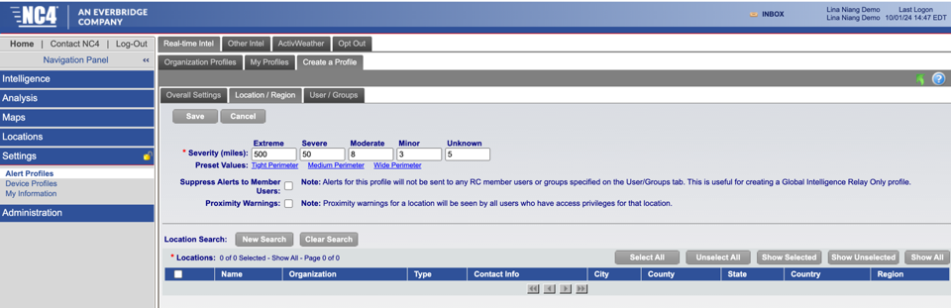

In Everbridge CEM Orchestration workflows this is equivalent to the condition selections in your filters, specifically Contacts and Assets, Severity and Radius.
NOTE: If a region/polygon shaped asset, the radius is N/A as the risk event must fall within the shape of the asset or the risk event shape needs to intersect with the asset shape.

In CEM Orchestration you can create a filter for each severity and radius combination, for example one filter if Severe then 10 miles, another filter if Moderate, 2 miles.

Severity, Contacts and Assets, and Radius condition in CEM Orchestration Workflow
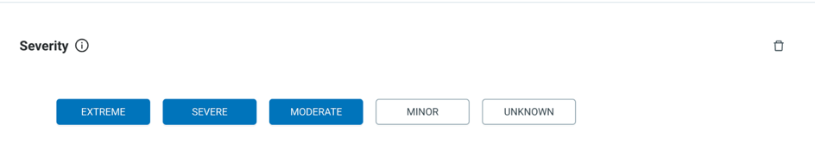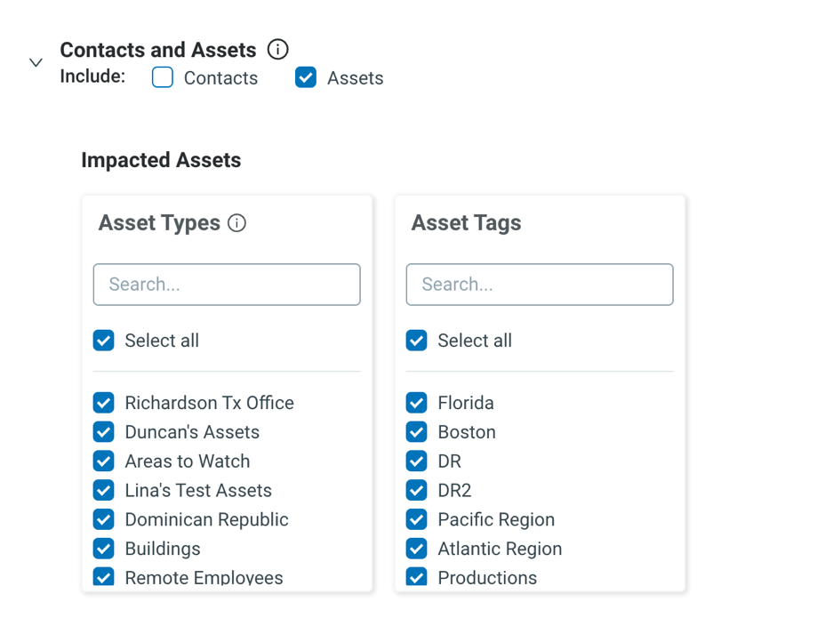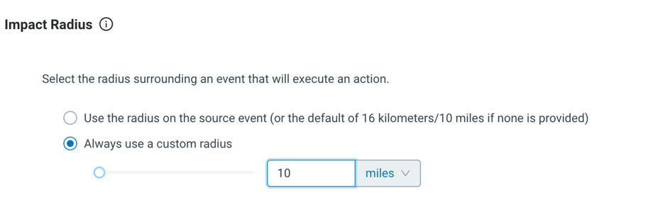

Real-Time Intel Profiles - Users/Groups
In NC4, this determines: (1) Users access to the alert profile, and (2) tying back to User’s device profiles and what delivery methods they receive the Alert notifications on.

In Everbridge, you cannot manage view/edit permission for CEM Orchestration workflows, it’s either the User can view/edit all workflows or none. You can control which Contacts receive a Notification of the workflow triggering an alert through the Action section of the workflow, the Incident Action and the ‘Who to Notify’. The setting section of the Incident Template selected determines the delivery methods the Alert Notification will launch to, and the Contacts on the template and the selected ‘When to Notify’ settings in the workflow determine who receives the Alert Notification.

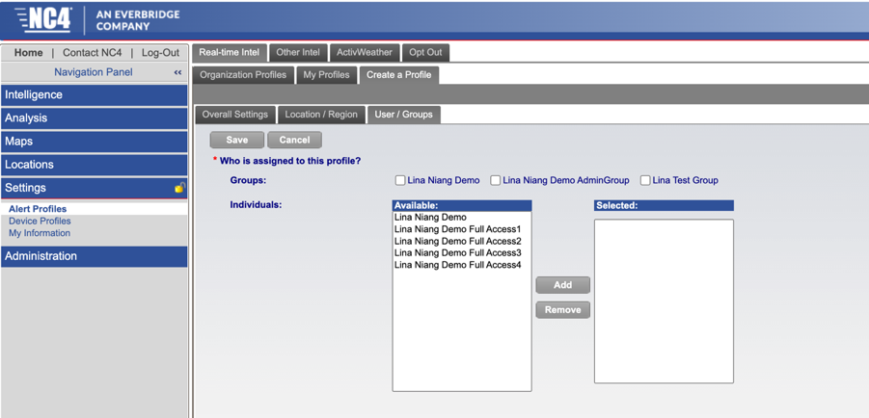

CEM Orchestration Workflow Action
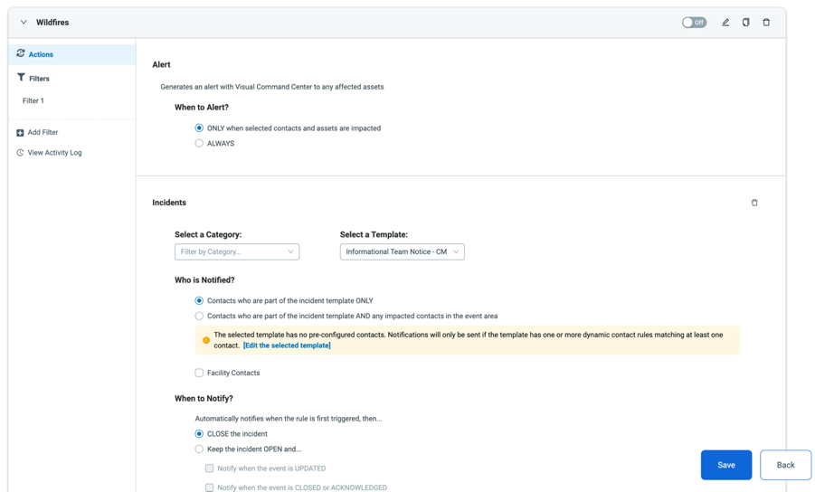

Incident Template Settings
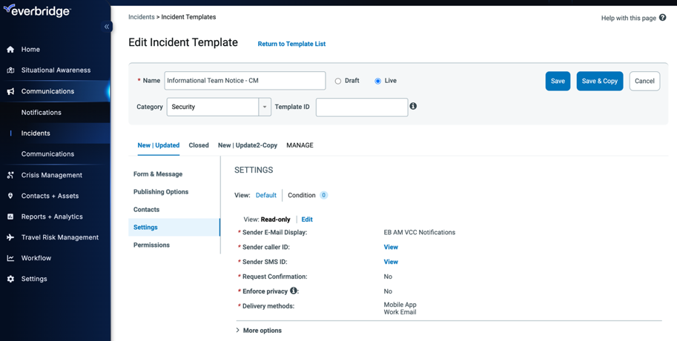
Other Intel Profiles - Alerts can be triggered for other intel types much like they can for Real-time incidents and advisories. Members with licenses for global content can receive alerts for Global Flashpoints, Country Reports and Country Risk Ratings. Alert Profiles can be set up to trigger alerts Situation Reports. Like Global Flashpoints, these intel types can be profiled based upon country/region, category, and severity.
Other Intel Alert Profile in NC4
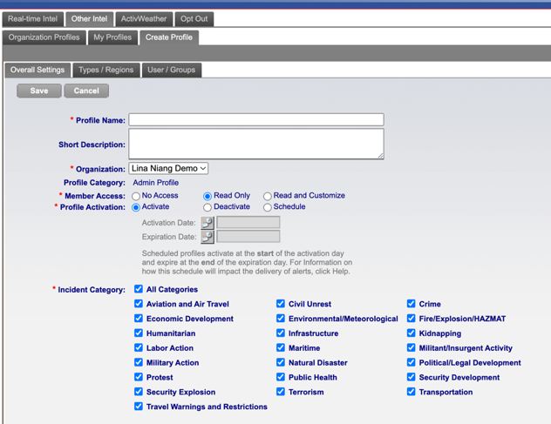
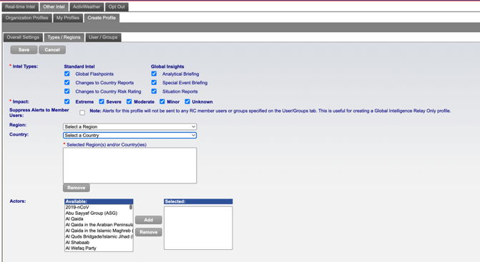
In Everbridge this is equivalent to creating CEM Orchestration workflows with the following sources: RIMC Global Flashpoints, and RIMC Situation Reports. Unless you are contracted for Everbridge Travel Protector you cannot receive Alerts on Country Reports and Country Risk Ratings, however you can reference and download this information from VCC Operator Console from the RIMC Country Rating contextual layer (shown earlier in the document).
Selecting by region or country is based on the assets/asset types you have created in your Everbridge Asset List, which then allows you to select these in the Contacts and Assets condition i.e., if a Severe RIMC Global Flashpoints or RIMC Situation Report is published within the North America Region Asset Type or the Building Asset Type and North America Asset Tag THEN, the Action is to ‘Always’ trigger an Alert and launch an Incident.
Sources, Severity and Category conditions in CEM Orchestration Workflows
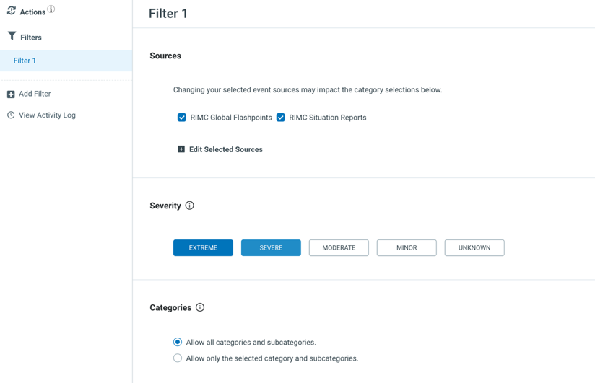

CEM Orchestration Workflow Action to ‘Always’ Alert
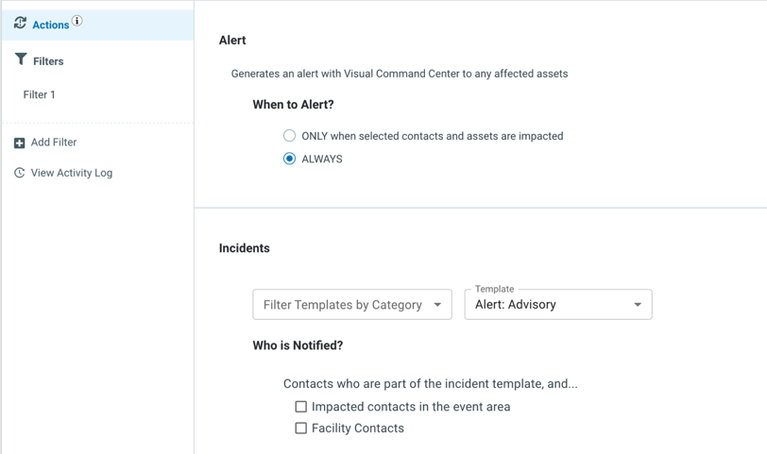

ActivWeather County Profiles - ActivWeather enables members to create customized weather profiles specific to their U.S. locations and preferences. Weather profiles can be customized with over 70 incident categories such as flash floods, dust storms, severe thunderstorm warnings, tropical storm warnings, volcano warnings, high surf warnings, high wind gusts, high rainfall rates, or by heat index and wind chill. Like other profile types, only incidents that meet your alert profile criteria will trigger an alert.

ActivWeather Alert Profile in NC4
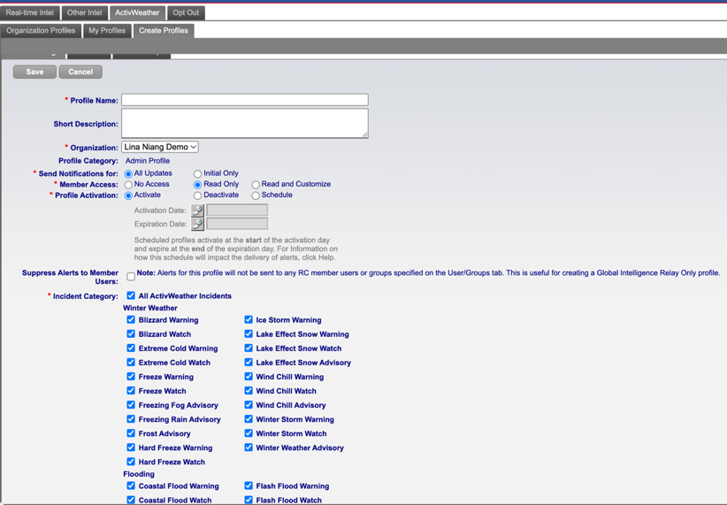

In Everbridge this is equivalent to creating CEM Orchestration workflows with the Weather Events (US) source defined in a filter. If an Asset (based on Contacts and Assets condition) falls within the shape of the Tornado Warning, or Winter Weather Advisory, or Air Quality Watch.

Weather Events (US) source, significance and category conditions in CEM Orchestration Workflows

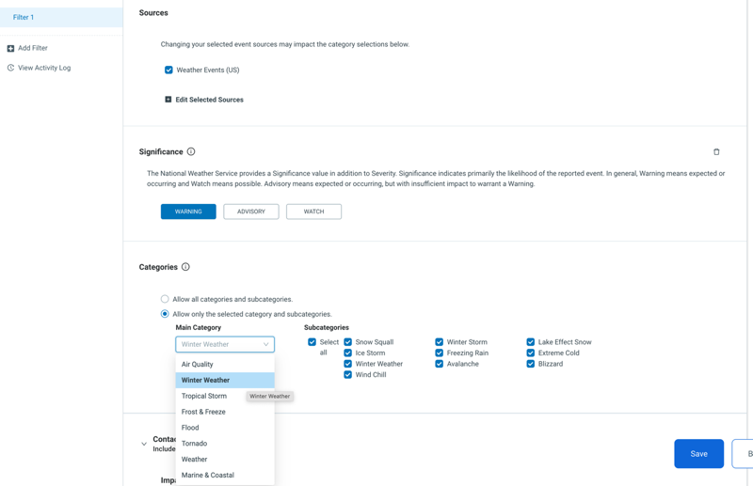

Device Profiles
Allow you to configurate the devices/contact information you will receive NC4 Alerts to. Each device profile can have up to four devices configured.

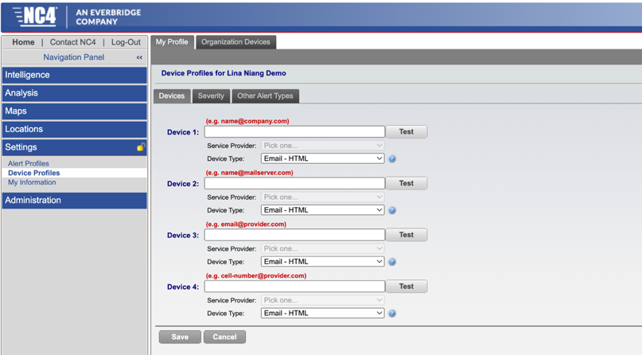

In Everbridge you configure the devices/contact information in the Everbridge Contact profile, and then you select the Contacts you want the Incident Notification to launch to, and the delivery method settings you want to launch the Incident Notification to. If the Contact has the delivery method defined, they will receive the VCC Alert Incident Notification to the appropriate device(s). The Incident Template selected in the Action section of the workflow determines the Message sent, Contact recipients and how the message is delivered to the Contacts.
Everbridge Contact Profile
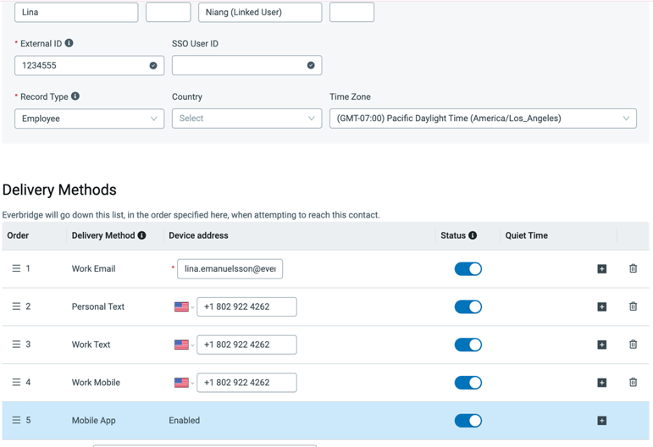

Everbridge Incident Template – Contacts
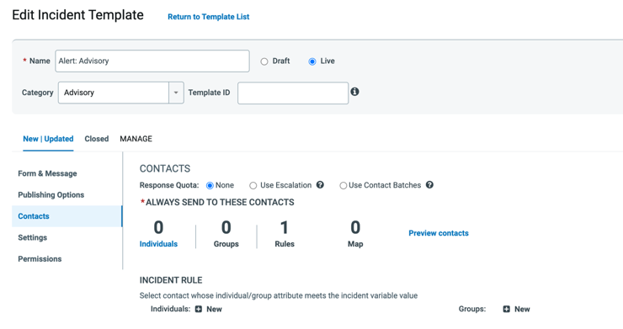

Everbridge Incident Template – Settings
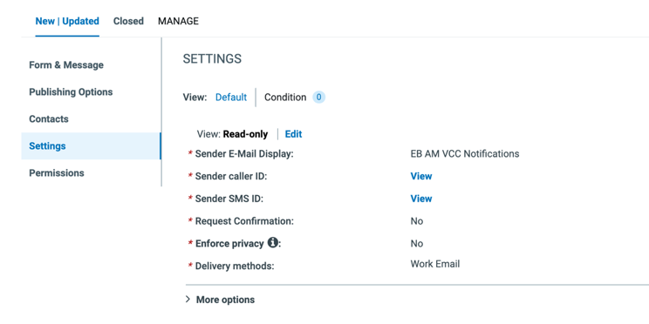

CEM Orchestration Workflow Incident Action
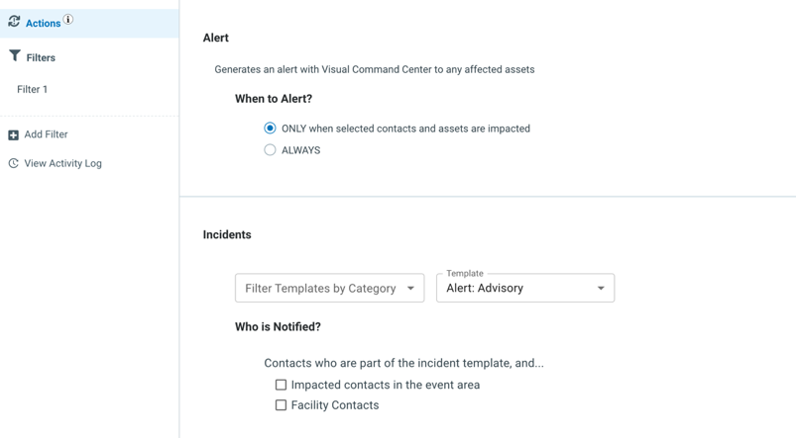

My Information
My User Profile is used to manage your personal user profile information. The contact information defined in the NC4 User profile is strictly for resetting your login password. The information defined here does not correlate with NC4 Alert profiles in any way.

The My Organization and My Groups tabs, as shown here, list the names of the Organizations, plus any Sub-organizations, and the groups that have been created by your NC4 Risk Center Administrator, and to which you have been associated.

My Information in NC4
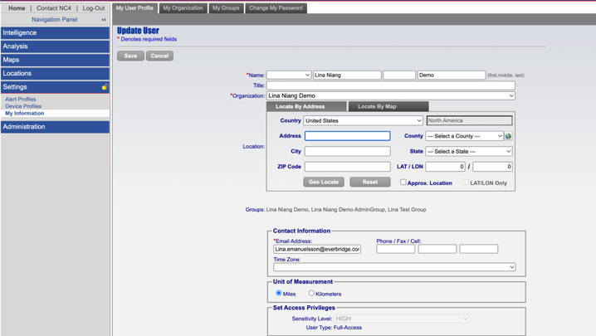

In Everbridge, the User profile and role assignment determines a what a User can see and do in Everbridge Suite Manager Portal and VCC.

Everbridge User Profile
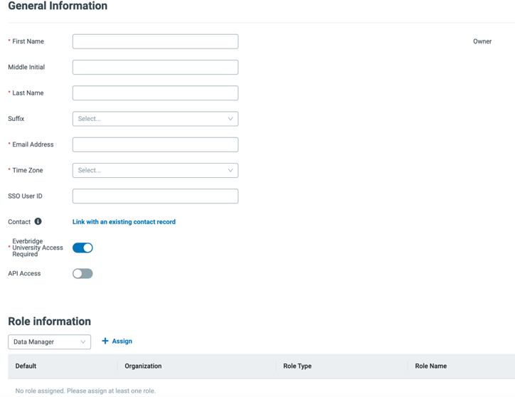

NC4 Administration
Four different types of accounts. These Accounts are created by NC4 Implementations based on what you are contracted for:
- Full Access (standard is 5 full access accounts) – a Full Access user profile corresponds with logging in to application and having access to a majority of left-hand navigation menu, can see Intelligence, Analysis, Maps, Locations and Settings.
- Organization Admin is a privilege that is granted to a full access license. An Organization Admin gets access to the Administration menu item in addition to the full access profile access.
- Alert Only – When a User logs in, they can only see the Setting section and can only create Alert profiles for their account, manage their device profiles (external notifications are sent), and manage their profile information (name, etc.)
- Mobile Only (only relevant to ActivPoint) – only logs in once to set up their password, terms of use, security questions, and then once they logged in then they are able to login to the app with those credentials. The app let’s them set up alert profiles and turn on location services so they can send their coordinates to the application and admins can see them on the situation map.

Organization and Sub-Organizations in NC4
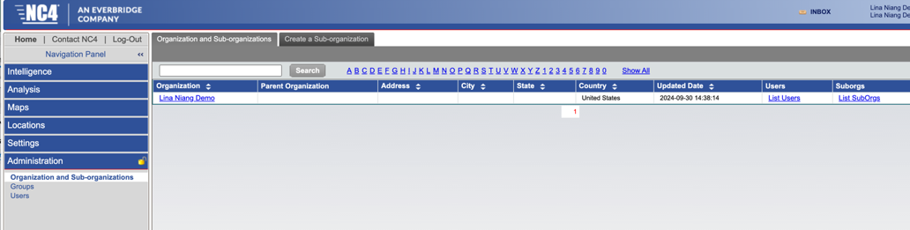

An Everbridge Account can have multiple Organizations within the Account. There is the Account-Level (accessible by Account Admins), and the Organization-Level accessible by all other role types. All Users assigned to the same role have the same access level in Everbridge. You can assign a User multiple Roles, and they can toggle between the Roles to access different feature components. There are 8 default role types, and a custom role option. The permissions and resources configured for the role controls what the role has access to.
Everbridge Account and Organization Hierarchy
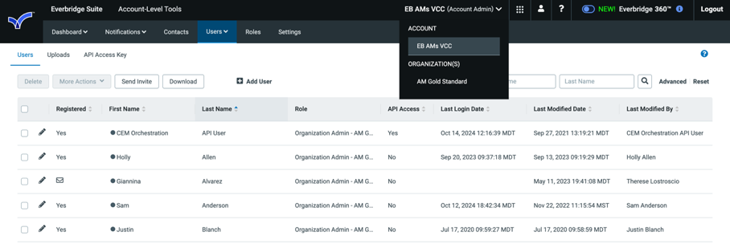

Creating a Default Role or a Custom Role in Everbridge
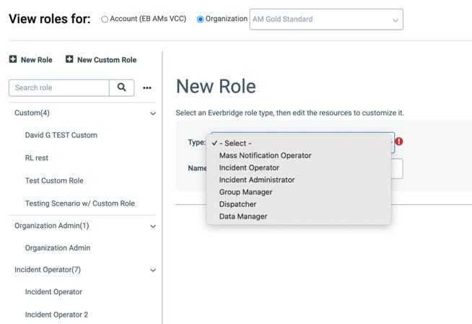
Role Permissions & Resources in Everbridge
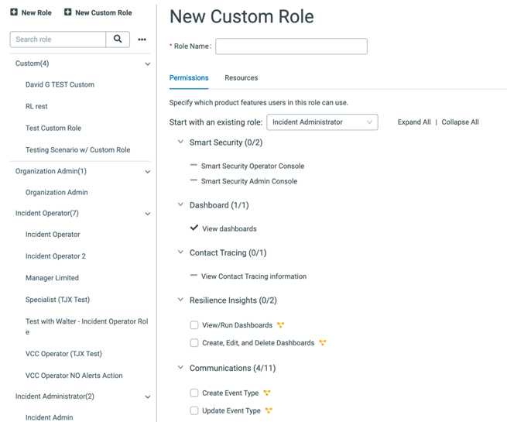

NC4 Inbox
The Inbox has three tabs: Alert inbox, intel inbox and non-alert inbox.
- The Alert Inbox contains alerts for RIMC, ISA, ActivWeather and ActivTravel.
- The Intel Inbox contains alerts for Analytical Briefs, Country Reports, Global Flashpoints, Special Event Briefings and Situation Reports.
- The Non-Alert Inbox contains location alerts that are sent when changes are made to a member’s qualifying location page.

NC4 Inbox
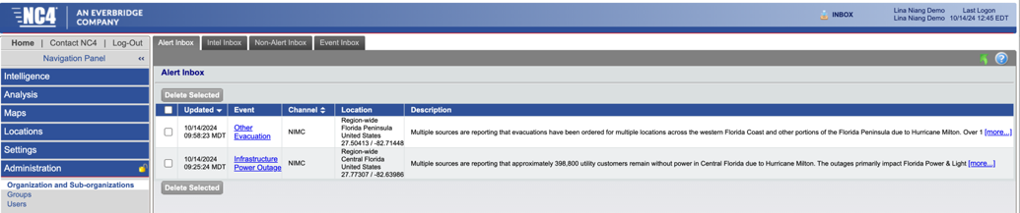

In Everbridge, you can view Alerts in the Alert feed in VCC Operator Console. This displays active Alerts in chronological order. You can also display acknowledged alerts over the last 90 days, and export active and acknowledged Alerts. You can view Alerts in an inbox style in the Alert Management menu item.

Alert Management Inbox in Everbridge
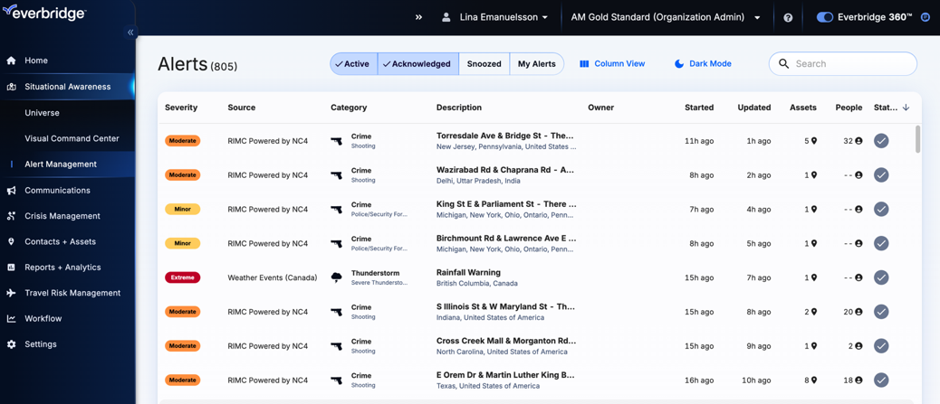

NC4 ActivTravel
NC4 ActivTravel is equivalent to the Everbridge Travel Protector product offering. With Everbridge Travel Protector, the Travel Risk Management menu item is enabled in your Everbridge Organization.

Situation Map
For ActivTravel members, the Situation Map also includes a map layer for Travelers, which displays your traveler information as airplane icons on the map. All active and pending traveler locations, including manually entered custom locations and Travel Management Company (TMC) -supplied hotel locations are displayed on the Situation Map according to their actual coordinates.

Clicking on a single airplane icon (one without the plus sign in the corner of the icon) pops up a window that shows the number of travelers with active and/or pending itinerary events in that location and allows you to drill down to the corresponding traveler itineraries, as shown in following image. Clicking the X Active / Y Pending link will provide a detailed list that includes the record locator, the traveler’s name and organization, as well as an envelope icon for each traveler with a valid email address. This icon can be clicked to launch the user’s default email client with a new message addressed to the traveler.

The pop-up also has controls at the bottom that allow the user to:
- Download as CSV data for Active and/or Pending travelers at the displayed location.
- Email All Active and/or Pending travelers at the displayed location.

Traveler Locations in NC4 Situation Map
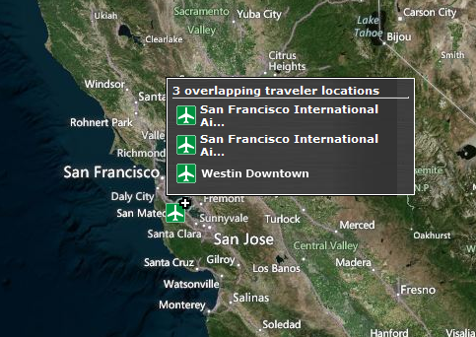

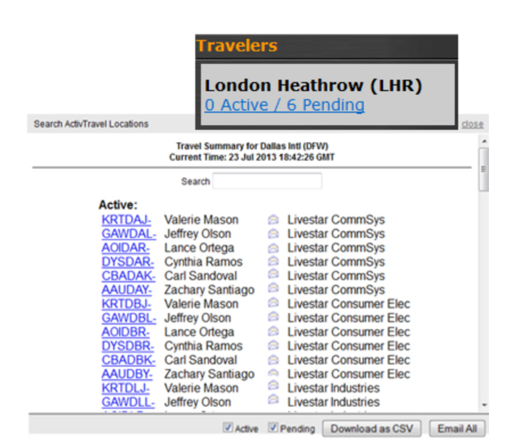

With Everbridge Travel Protector, you can display travelers on the VCC Operator Console map. In addition to visualizing the travelers on the map, and view itinerary information on the Items Panel, you can manually export a list of travelers in csv format, and you can launch an Incident Notification to the travelers.

Travelers/Travel Itineraries in VCC Operator Console
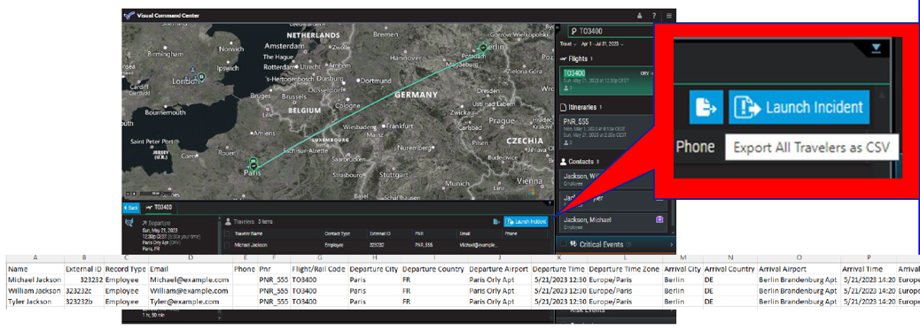

NC4 Travelers
Reports - Traveler Reports provide travel managers quick access to their traveler data.

Executive Summary - displays the last reported locations for your travelers, expatriates, and dependents, and the Country Risk Rating for each of the countries of travel.
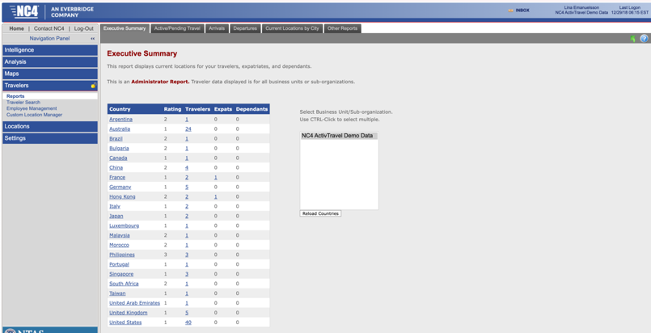

In Everbridge Travel Protector, under Travel Risk Management you can create custom Travel Reports with the Travel Segment Report Type. You can drag and drop which data fields you would like to include in the report and data filters (if applicable) and then you can search by ‘Now’, ‘Specified Range’ or ‘Custom’ in terms of
time.

Custom Travel Report in Everbridge
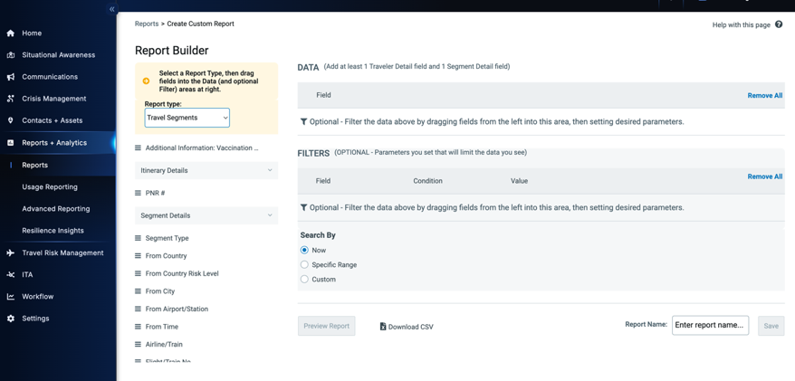

Active/Pending Travel - The Active/Pending tab provides a list of the active and pending itineraries for your travelers, listed by Country destinations as shown below. The number listed in the Active column indicates the number of travelers currently in that country. The number listed in the Active/Pending column indicates the number of active and pending itineraries for the country. You can download a copy of the active destinations report to a CSV file by clicking the Download to CSV link at the bottom of the window.
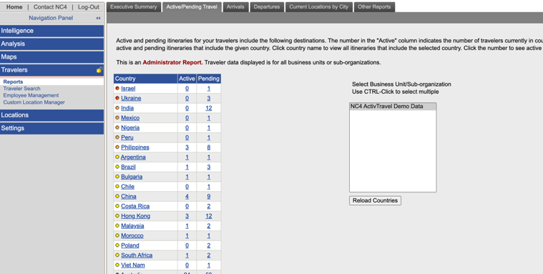

In Everbridge Travel Protector, this is equivalent to the Country Risk Traveler Report under Travel Risk Management menu item.
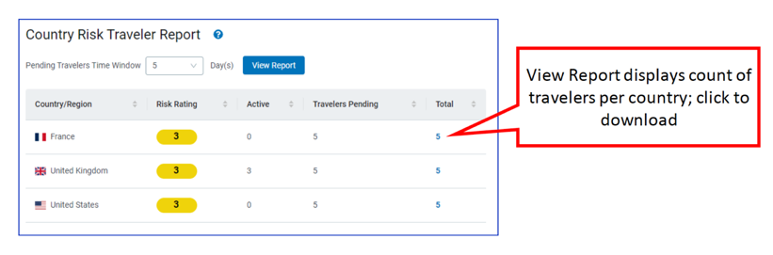

Arrivals - The Arrivals Report shows all air arrivals to the selected location over the date range specified.

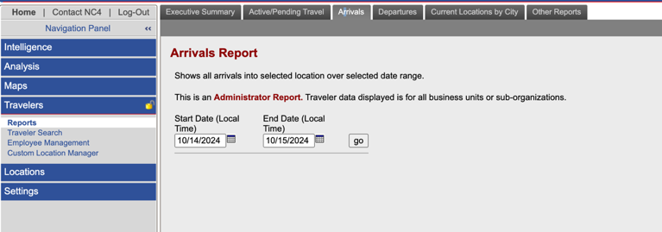

Departures - The Departures Report shows all air departures from the selected location over the date range identified.
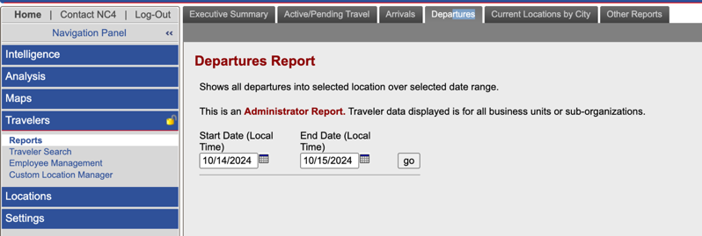

In Everbridge Travel Protector, this is equivalent to the Arrival and Departure Report.

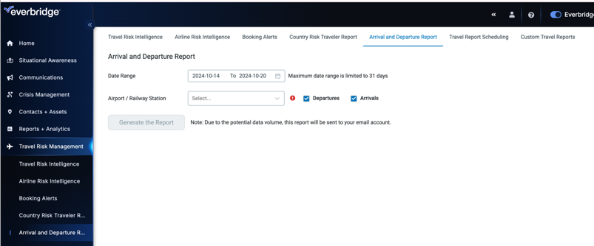

Current Locations by City - The Current Locations by City report lists active travelers by location.

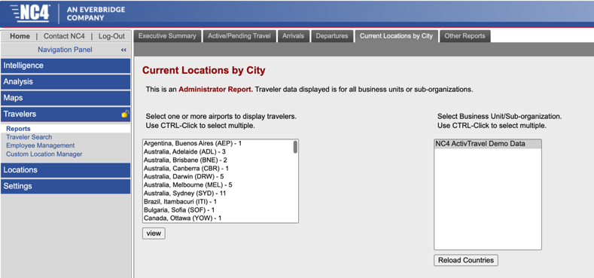

In Everbridge, you can create a Custom Travel Report that will include this information (as displayed earlier).

Other Reports - 2+ On Flight Report: Displays a list of all pending flights with two or more travelers scheduled to fly together. Information about each passenger is available, as well as the arrival and departure airports for each flight.

In Everbridge Travel Protector, you can create Booking Alerts based on ‘Travelers on the same plane’ and automatically send an Incident Notification to Contacts for awareness. Manually, you can search to Flight # in the search field in VCC Operator Console and identify travelers with the flight number in their itinerary and you can download a csv of these travelers.

Traveler Search
In NC4 you can search travelers by travel itinerary parameters to access their full itinerary information.
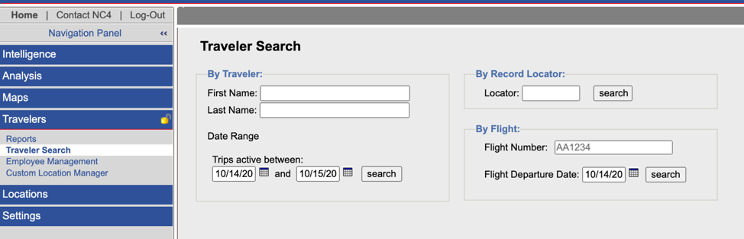

In Everbridge, you can search and visualize travelers and travel itinerary information in multiple areas.
- In VCC, you can filter the Operator Console to only show Contacts with a Travel location type, you can filter by travel segment and by time.

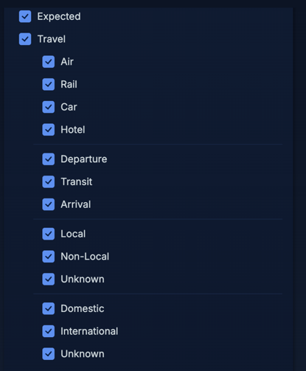

- You can also search travelers in the search bar. Available filters: All, Alerts, Assets, Contacts, People, Places, Risk Events, Travel - Includes all travel segment types (Flights, Train, Hotel, Car), itineraries and travelers. Available Time frames: Timeline, Last 14 days, Last 7 days, Current, Next 7 days, Next 14 days, custom range.

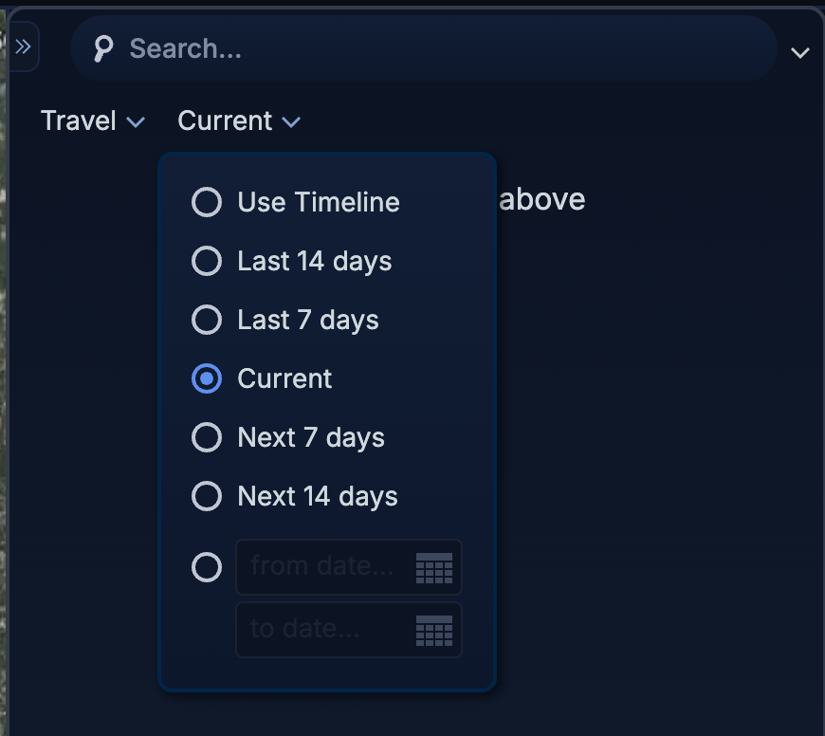

- You can search travel itineraries in the Travel Connectors and API Log under the Contacts/Assets menu item.

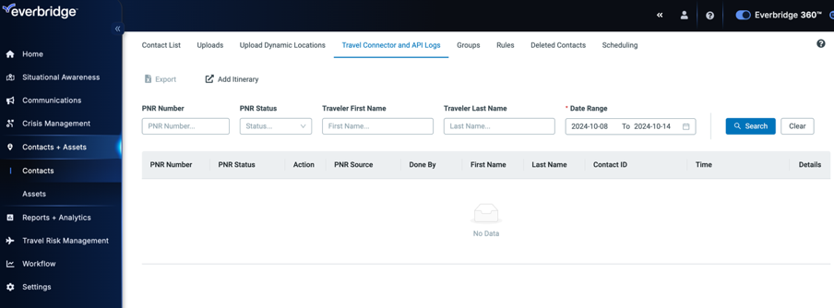

Employee Management – Manually creating Itineraries
In NC4, you can create a new itinerary manually, by selecting the employee or searching the employee. Under employee detail records you can add a trip and select the segments you would like to add.

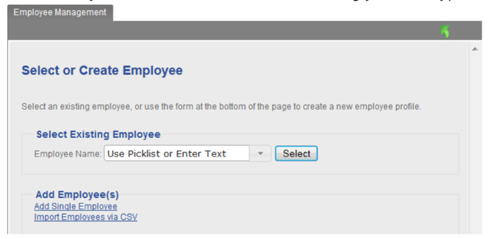

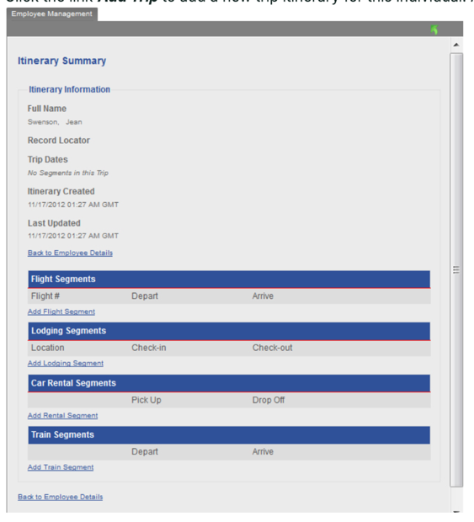

In Everbridge, you can only manually import itineraries through a spreadsheet, you cannot add the manually in the UI under a contact profile. Instructions for downloading and using the importer utility are provided by clicking the “Add Itinerary” link under Contacts/Assets > Travel Connectors & API Logs.

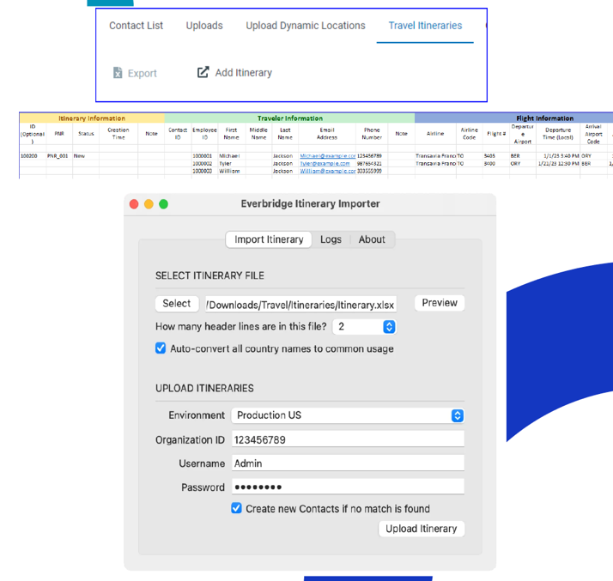

Create a Traveler Alert Profile
Create Alert profiles based on travelers locations is similar to location based alert profiles. Travel alert profiles are triggered based on dynamic active and pending traveler locations at the time of an Incident. Alerts triggered by Traveler profiles are delivered directly to the traveler based on the email address in the travel itinerary.

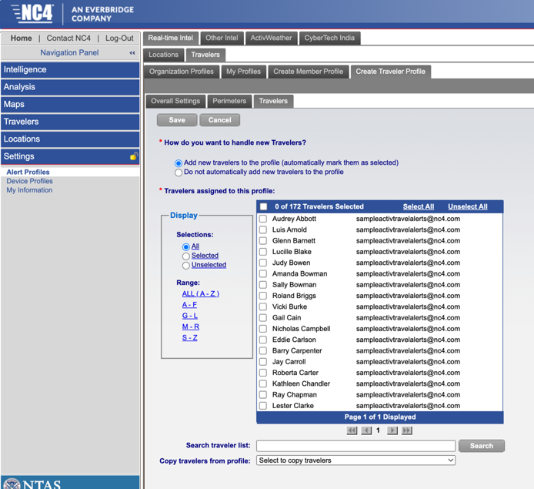

In Everbridge, you can create CEM Orchestration workflows with the Contacts and Assets condition set to Contacts and Expected Location Type or Travel Location Type. You can then have the Action of launching an Incident send to Contacts in the impacted area i.e., to the traveler.

Creating Traveler specific alert thresholds in CEM Orchestration Workflows
