CEM Orchestration Workflow
Tips & Tricks

Managing VCC Alert Thresholds:
- Our simple and legacy alert rulesets are available in the VCC Admin Console under VCC Alert Settings.
- Our more advanced alert rulesets, CEM Orchestration Workflows were introduced in May 2023, and are accessible in Everbridge Suite Manager Portal under Settings > Everbridge Open > CEM Orchestration.

You can have alert thresholds configured in both VCC Alert Settings and CEM Orchestration Workflows. The system will evaluate both. If the alert thresholds overlap, only one Alert will trigger in VCC Operator, however, if Auto-Incidents are configured in both sets of alert thresholds, multiple Auto-Incidents will launch.

CEM Orchestration Workflow Value-Adds
Common use cases/value adds for CEM Orchestration workflows compared to VCC Alert Settings in the VCC Admin Console:
- Vary the radius by severity creating a filter for each
  - Minor shooting = 0.5 mile radius
  - Moderate shooting = 1 mile radius
  - Severe shooting = 5 mile radius
  - Extreme shooting = 25 mile radius
- Set different alerting rules based on what Assets are impacted through asset types, asset tags or asset association
- Set different alerting rules based on who is impacted through contact record types, groups or location type
- Manage workflows by risk event type (category/subcategory) rather than by risk event feed/source
- Configure multiple Auto-Incident templates to launch to different stakeholders

Anatomy of CEM Orchestration Workflows
The CEM Orchestration Workflows page contains workflows, rules, and filters. Each are described below.

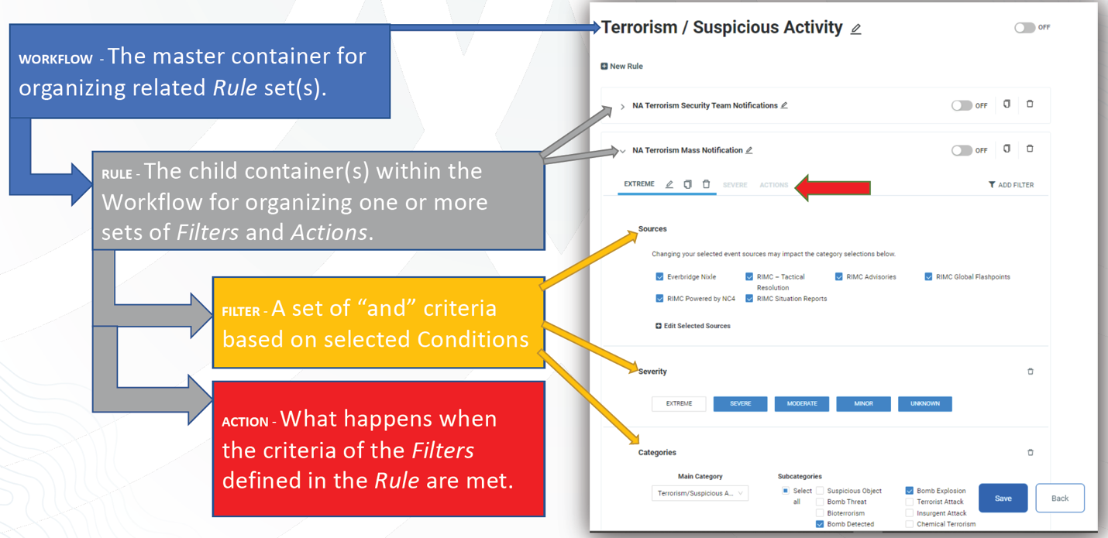

It is up to your organization how you would like to structure and organization your CEM Orchestration workflows. Each workflow, rule and filter should be named accordingly to easily identify where to an alert threshold is being managed.

Outlined below are scenarios for creating multiple Rules within a workflow:
- Met the max of five filters per Rule
- Different actions for different filter criteria
- Personal preference for structure and organization of workflows

There are several required conditions and/or system default conditions pre-selected in each filter:
- Sources – select which risk event feeds/sources you would like to alert on. Multiple sources can be selected, but note the source selection determines the category condition selections and additional condition options. See more information in the Sources section.
- Categories - limited to one category or all categories/subcategories of the source(s) selected. More information in Sources section.
- Contacts and Assets – select the Contacts and/or Assets that you would like to be considered alertable data for the filter. More information in the Asset Management section.
- Radius – proximity of risk event to alertable assets. There are two options: (1) always use custom radius (km, miles, feet, and meters), (2) use the radius on the source event (if no radius is defined default is 10 miles/16km). We only recommend using the radius on the source event selection if the risk event feed/source reports polygon shaped events vs. geo-point-based events.

The remaining conditions are optional: Severity, Time Frame, and unique conditions to a source e.g., Wind Swath, Significance, and Magnitude.

Sources
***IMPORTANT NOTES
Source(s) is a required condition within each filter. The source selection determines the additional conditions that can be defined e.g., category and subcategory selections, unique conditions to the source e.g., magnitude, significance, wind swath, etc. You do not want to select multiple sources if category and subcategory mapping are not identical, unless you are creating a filter that alerts on all categories and subcategories of the sources selected. For example, you are creating a workflow for Earthquakes, Earthquakes are reported by RIMC and by Earthquakes (USGS). For RIMC powered by NC4 and RIMC Advisories, Earthquake is a subcategory of the Natural Disaster Category. Earthquakes (USGS) has the one Earthquake category. If you select both sources, the category selection will be a drop-down list of all categories available across each source. You are limited to one category selection per filter (or all categories and subcategories), if you select Earthquake category, no Earthquakes published through RIMC will meet the filter criteria, if you select Natural Disaster, no Earthquakes published by Earthquakes (USGS) will meet the filter criteria. In this case you would want to create a filter for each source. Also, you do not want to selected multiple sources in one filter if one of the sources has a unique condition. For example, Earthquakes (USGS) reports on magnitude. This is the only source with this condition. RIMC powered by NC4 and RIMC Advisories reports on severity by Minor, Moderate, Severe, or Extreme. If the magnitude condition is defined, earthquakes reported by RIMC sources will never meet the filter criteria.

Below is a list of sources that you can combine based on like categories, subcategories or severities.
- RIMC Powered by NC4, RIMC Advisories, RIMC COVID-19, Operator Entered Risk, Everbridge Nixle and third-party risk intel such as Dataminr, International SOS, etc.
- RIMC Situation Reports and RIMC Global Flashpoints only report to the Other Security category. NOTE: If you are creating a filter criteria with the Other Security category you can combine with RIMC Powered by NC4, RIMC Advisories, Everbridge Nixle, and third party risk event feeds such as Dataminr, International SOS, etc.
- Weather Events (US) has significance condition: Watches, Advisories and Warnings
- Weather Events (Canada), Weather Events (Australia), Weather Events (Japan) and Weather events (Canada)
- Earthquakes (USGS) has a magnitude condition.
- Tropical Storm and Cyclones (NHC)
- Wildfires (NIFC)
- Hurricane (GDACS)

The National Weather Service provides a Significance value in addition to Severity. Significance indicates primarily the likelihood of the reported event. In general, Warning means expected or occurring and Watch means possible. Advisory means expected or occurring, but with insufficient impact to warrant a warning. We recommend using both Significance and Severity conditions for the Weather Events (US) source.

Sources we recommend selecting ‘Always Alert’ meaning regardless of the proximity to my contacts and assets: RIMC Global Flashpoints, RIMC Situation Reports, and Tropical Cyclone and Disturbances (NHC).

Sources that publish polygon shaped events vs. geo-point-based events:
- Weather Events (US)
- Weather Events (Europe)
- Weather Events (Canada)
- Weather Events (Japan)
- Weather Events (Australia)
- Wildfires (NIFC)
- Hurricanes (GDACS)
- Tropical Storm and Cyclones (NHC)

This means your alertable Contacts and Assets must fall within the shape of the event, rather than a certain distance from the event. The radius condition is N/A for these sources, and as a default we recommend defining ‘use radius on source event’ selection.

Asset Management – Asset Types, Asset Tags and Asset Association
Asset Types
An Asset Type must be defined before you can add Assets to the system. You can define multiple Asset Types depending on (1) your visualization needs, and/or (2) alerting needs. It’s a great way to categorize your assets i.e., manufacturing sites, corporate offices, data centers, supply chain locations, division 1, division 2, etc.

NOTE: Asset Types are managed separately. You cannot have one file upload that manages assets across all asset types. From an asset management perspective, if you prefer one file upload to manage all assets, Asset Tags will be the recommended option, and you can use Asset Tags to differentiate assets as needed.

Asset Tags
Asset Tags are additional attributes that allow you to organize and group your assets for alerting and notification purposes. If all Asset Tags are selected, then Asset Tags are ignored.

Creating Asset Tags:
- Create Asset Tag as a custom attribute in the Asset Type Organization Settings.
  - An Asset Tag must be configured for every Asset Type that will use the Tags.
  - Attribute name must be “Tags” (case- sensitive), must be a multiple selection list display format, and a Text data type.

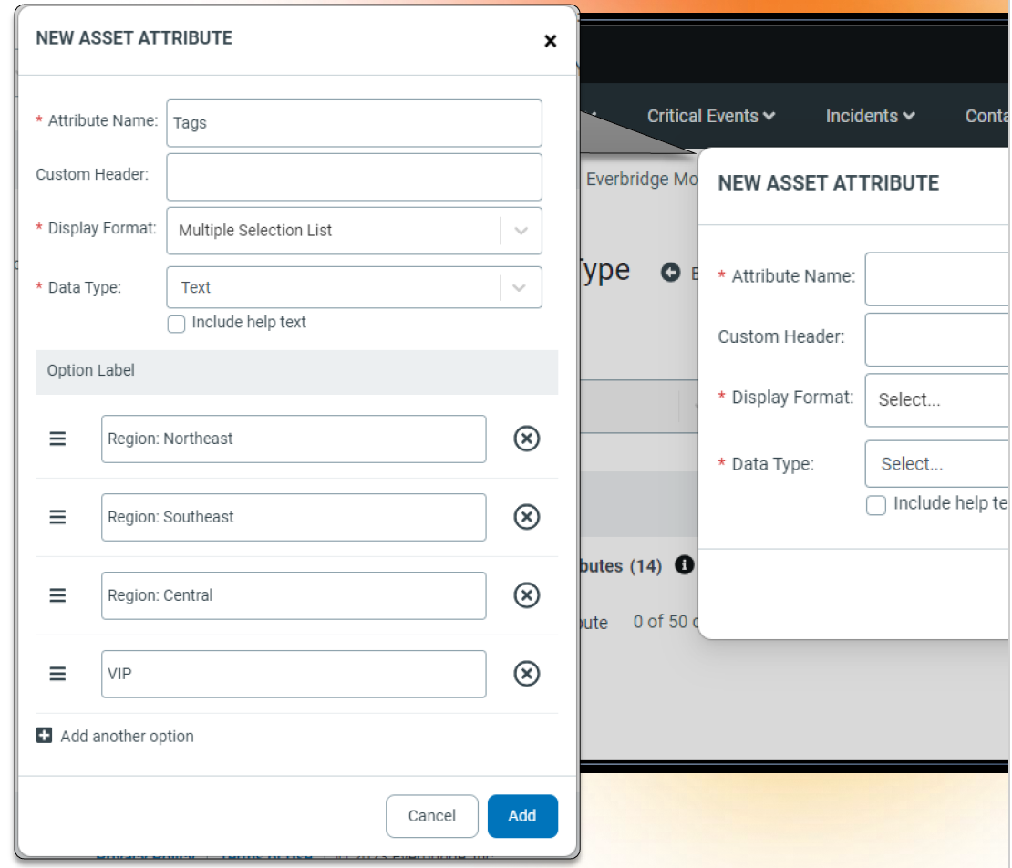

- Define Asset Tag in Asset profile
  - You can add multiple Tags to an individual Asset, enabling you to include a given asset in multiple logical groups.

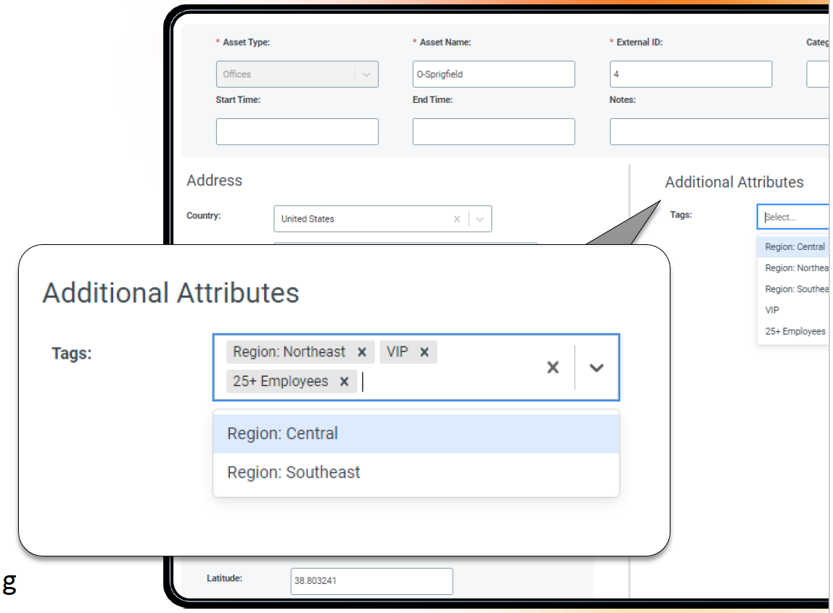

- Define Asset Tag in the Contacts and Assets condition in CEM Orchestration Workflows.
  - Once you have tagged Assets, you can use those tags in your CEM Orchestration Workflow filter conditions to more precisely target alerts and notifications.
  - Just add the appropriate tags to your filter conditions for your assets in your workflows to match the asset groups you want.
  - Asset Type and Asset Tags are required selections and behaves as AND logic i.e., an Asset must meet the Asset Type selection and the Asset Tag selection.
  - NOTE: If you want your filter to match Assets with no tags check “Select All”, as that will match all possible configurations of tags, including no tags.

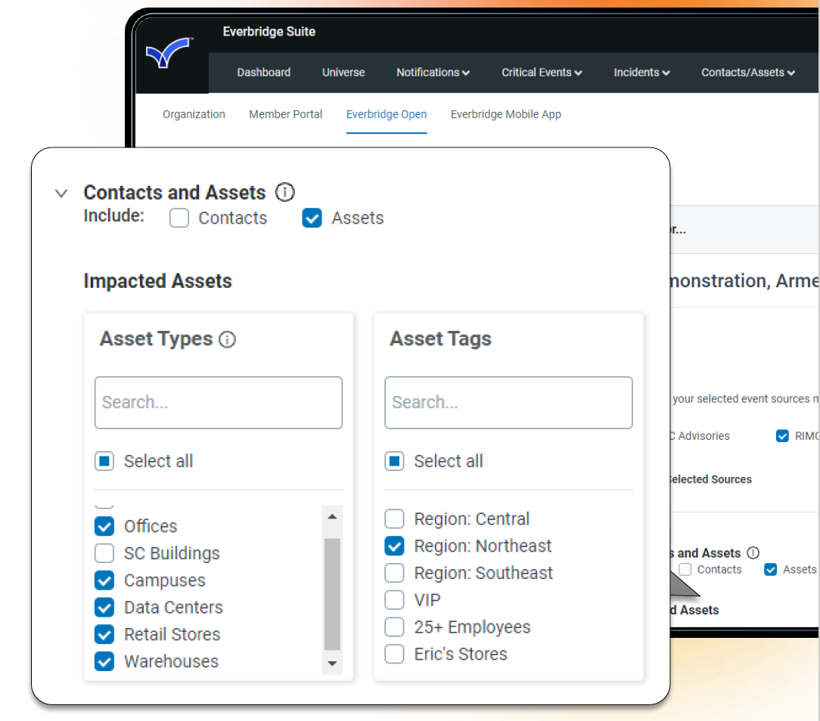

Asset Association is now available in your Everbridge system. It’s a three-step process to configure:
- Asset Association Definition – Add an Asset Association definition to reach asset stakeholder role you want to notify e.g., Store Manager, Regional Manager, District Manager. This can be configured by going to Settings > Organization > Contacts/Assets > Asset Association.
- Asset Stakeholder Assignment – Associate Contacts with specific Assets to act as stakeholders. In the Asset profile you can define the individual or Group for each asset stakeholder role. You can do this manually in the user interface, manual bulk csv upload, SFTP or API
- Workflows – In the CEM Orchestration workflows, under the Action section and Incidents, select ‘Facility Contact’ checkbox. You can then select the asset stakeholder roles you would like the Auto-Incident to launch to when the Asset is impacted.

Actions
By default, the action will ‘Alert’ in VCC Operator Console.
- ALWAYS – Trigger an Alert regardless of the proximity to Contacts and Assets. Only evaluate the other conditions i.e., source, category/subcategory, and severity.
- ONLY when selected contacts and assets are impacted (based on contact and asset condition)

You can add Incident(s) if you would like an Incident to automatically launch when the Alert is triggered.
NOTE: If the Auto-Incident Templates includes Affected Asset variables, the list of affected assets could include all assets affected by the Alert (based on other workflows and rulesets), not just the Assets defined as alertable for the workflow that triggered the Incident. If there is another workflow that has the other assets defined that also met the Alert, they will be included in the list of affected assets in the Incident.

We recommend including the following system autofill variables in your Auto-Incident Templates to be able to reference back which workflow and ruleset triggered the Incident.
_CEM Triggering: Workflow Name
_CEM Triggering: Workflow ID
_CEM Triggering Ruleset Name
_CEM Triggering Ruleset ID

Contacts are Alertable setting in VCC Admin Console vs. Contacts and Assets condition in CEM Orchestration Workflows

Contacts are alertable IF (1) they are marked as alertable under VCC Admin Console > Data > Contacts or (2) if they are selected in the Contacts and Assets condition within a filter.

If Contacts are marked as NOT alertable in VCC Admin Console, but Contacts are selected in the Contacts and Assets condition in a filter, THEN Contacts are alertable for that use case filter.

Under the Action section, if an Incident is configured and ‘Contacts who are part of the incident template AND any impacted contacts in the event area’ is selected, this only applies to Contacts who meet the filters applied in the Contacts and Assets filter. Contacts have to be selected in the Contacts and Assets condition in order to automatically send the incident to impacted Contacts in the event area.

Under the Action section, if an Incident is configured and if Facility Contacts is selected, then Contacts do not have to be configured in the Contacts and Assets condition. This ties back to the Asset that is alertable.

